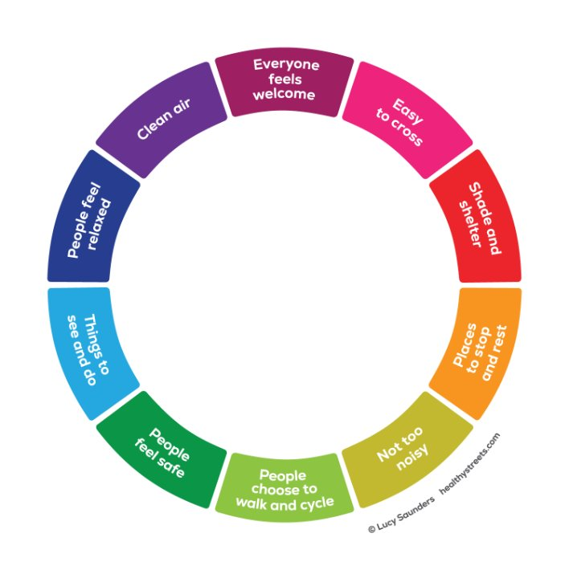

S278 Healthy Streets Checklist

Project: |  | HDP Reference: | 6/
Developer: |  | MasterGov Ref:
Developer’s Design Consultant: |  | HDP Officer:
HCC Project No. | R.J or C.J





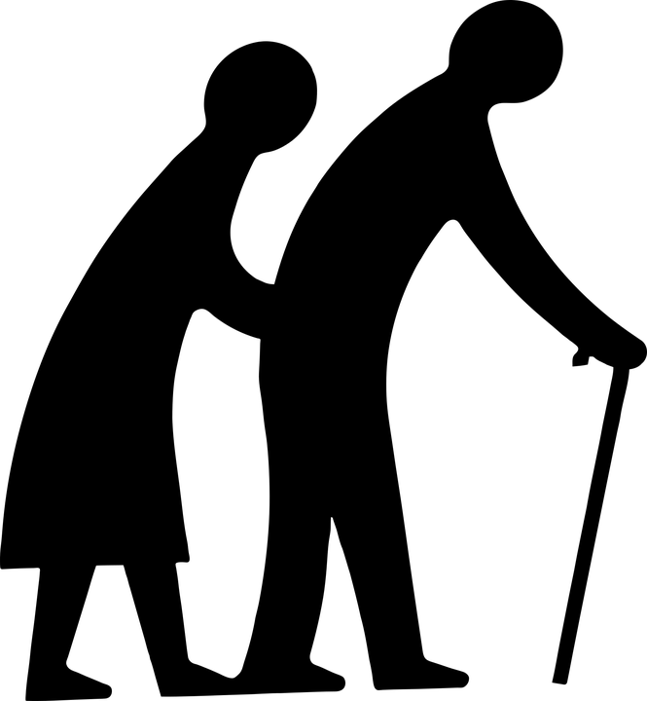

 | Pre-Planning / Planning |  |  | Detailed Design |  |  | Substantial Completion
 | Is there? | Incl. in design? | If not included in design, provide reasoning | Is there? | Incl. in design? | If not included in design, provide reasoning | Incl. in design? | If not completed, provide reasoning
Missing or incorrect tactile paving
Missing dropped kerb
Dropped kerb that can be moved to desire-line
Opportunity to narrow side road entrance and/or tighten priority junction corner radii
Assess whether appropriate to have raised/side road treatment in accordance with TG2 and 10
Opportunity to narrow/raise cross-over
Redundant dropped kerb to remove
Crossing point (away from junction) that could be raised table. Not appropriate on P1 salt route or primary street.
Opportunity to reduce the gradient of existing crossing points that have overly steep gradients
Missing section of footway
Opportunity to increase the clear level width for walking on the footway to at least 2m wide
Opportunity to increase the clear level width for cycling to be in accordance with LTN1/20
Signage that could be removed, resized, consolidated, de-illuminated
Signage that could be repositioned
Bollard /guard railing that could be removed. To be assessed by Road Safety Auditor familiar with “Healthy Streets” to confirm not required for safety.
Bollard /guard railing that could be replaced with a Sheffield stand, seat or planter
Inset parking/loading bay that could be raised
Redundant access/crossover that can be reinstated. Consultation with HDP required.
Opportunity to add seat (ideally maximum of 100m between seating)
Opportunity to add tree
Opportunity to add cycle stand (ideally maximum of 100m between cycle stands)
Opportunity to widen footway
Phone box that could be removed
Opportunity to improve accessibility to a bus stop
Opportunity to add a shelter/seat at a bus stop
Road markings that could be removed
Could any speed cushions be replaced with a raised table to facilitate crossing (provided there is adequate visibility)
Footway/cycleway that could be levelled or footway defects that could be addressed
Parking/loading bays that could be removed or reconfigured
Opportunity to add buildouts to slow traffic, widen footways, accommodate growth of mature trees
Gully cleaning/drainage improvements
Temporary clutter to be removed e.g. a-boards/fly tipped rubbish
Broken street light to be repaired
Opportunity to incorporate a controlled crossing facility to any appropriate arms (subject to need/traffic flow – Refer to TG10 and TG4-2)

Additional actions or comments
Text here.

