How many
units did
you drink
last week?
This is one unit. For more detailed information on calculating units see https://alcoholchange.org.uk/alcohol-facts/interactive-tools/unit-calculator

1.5
Half pint of | Half a small | 1 single | 1 small | 1 single
“regular” regular | glass of | measure of | glass of | measure of
beer, lager  or cider | wine | spirits | sherry | aperitifs

A pint of “strong” or” “premium” beer, lager
or cider
There is no completely safe level of drinking and drinking even small amounts of alcohol can incur risk in certain circumstances.
For example, with strenuous exercise, operating heavy machinery, driving or if you are on certain medications.
If you are pregnant or planning a pregnancy, the safest approach is not to drink alcohol at all.
Drinking in pregnancy can harm the baby, with the more you drink the greater the risk.
The risk of harm to the baby is likely to be low if a woman has drunk only small amounts of alcohol before she knew she was pregnant or during pregnancy.
This leaflet is based on the “How Much Is Too Much?” Simple Structured Advice Intervention Tool, developed by Newcastle University and the Drink Less materials originally developed at the University of Sydney as part of a W.H.O. collaborative study.


...and each of these is more than one unit.
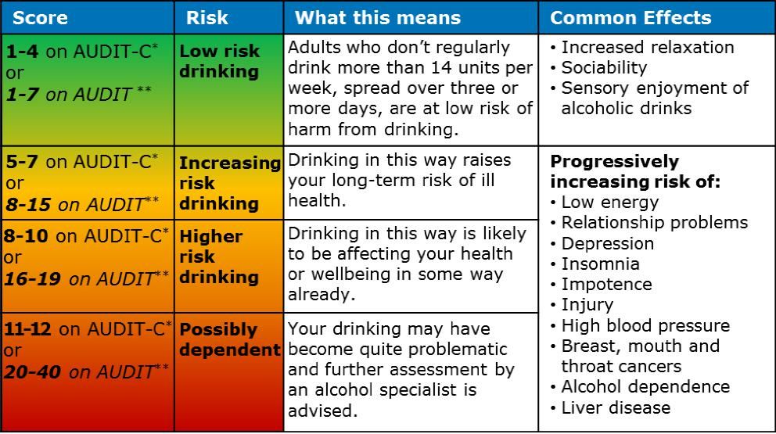
*Short 3 question AUDIT questionnaire. **Full 10 question AUDIT questionnaire

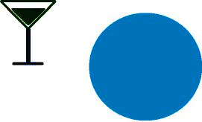
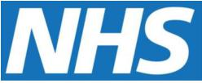

9
Alcopop or a
275ml
bottle of
regular
lager

A pint of
“regular”
regular
beer, lager
or cider
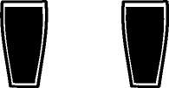
2
3
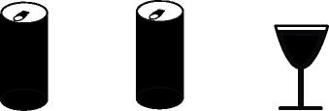
3
4
2
440ml can | 440ml can | 250ml glass | Bottle of
of “regular” | of “super | of wine | wine
lager or  cider | strength”  lager | (12°Io) | (12°Io)

What’s everyone else like?
Source: Health Survey for England 2022

The potential benefits of cutting down.
Psychological/Social/Financial
- Improved mood
- Improved relationships
- More time for hobbies and interests
- Save money
Physical
- Better sleep
- More energy
- Lose weight
- Reduced risk of injury
- Improved memory
- Better physical shape
- Reduced risk of high blood pressure
- Reduced risk of cancer
- Reduced risk of liver disease
- Reduced risk of brain damage
Making your plan
- Have several ‘drink-free’ days, when you don’t drink at all.
- When you drink, set yourself a limit and stick to it.
- Quench your thirst with non-alcohol drinks before and in-between alcoholic drinks.
- Avoid drinking in rounds or in large groups.

- Eat when you drink - have your first drink after starting to eat.
- Switch to lower alcohol beer/lager
- Avoid going to the pub after work.
- Plan activities and tasks at those times you would usually drink.
www.rethink-your-drink.co.uk

- When bored or stressed do something physical instead of drinking?
- Avoid or limit the time spent with “heavy” drinking friends.
What targets should you aim for?
www.nhs.uk/better-health/drink-less/

There is no completely safe level of drinking, but by sticking within these guidelines, you can lower the risk of harming your health:
- Adults are advised not to regularly drink more than 14 units a week.
- If you do drink as much as 14 units in a week, spread this out evenly over 3 or more days.

What’s your personal target?


Some brief advice
about alcohol and your
health

