Alcohol Brief & Extended Brief Intervention Guidance

This alcohol brief & extended brief intervention guidance consists of the questions from the full alcohol use disorders identification test (AUDIT) and provides step by step gudiance to support practitioners in having healthy conversations about alcohol.

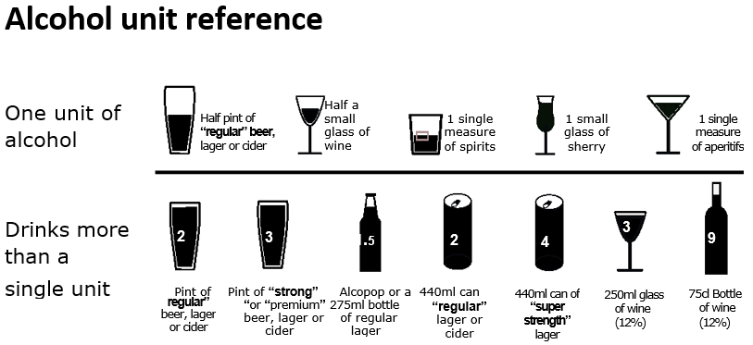

For more detailed information on calculating units see https://alcoholchange.org.uk/alcohol-facts/interactive-tools/unit-calculator

AUDIT C screening questions:
For gudiance on initiating and structuring alcohol conversations see the crib sheet resource below
Questions | Scoring system |  |  |  |  | Your  score
Questions | 0 | 1 | 2 | 3 | 4 | Your  score
How often do you have a drink containing alcohol? | Never | Monthly  or less | 2 to 4  times  per  month | 2 to 3  times  per  week | 4 or more times per week
How many units of alcohol do you drink on a typical day when you are drinking? | 0 to 2 | 3 to 4 | 5 to 6 | 7 to 9 | 10 or  more
How often have you had 6 or more units if female, or 8 or more if male, on a single occasion in the last year? | Never | Less  than  monthly | Monthly | Weekly | Daily or  almost  daily
AUDIT C score:
Scoring the AUDITC: A total of 5 or more is a positive screen:
(0-4 Lower risk, 5-7 Increasing risk, 8-10 Higher risk, 11-12 Possible dependence).

What to do next
If the person has a score of 4 or less, congratulate and state benefits of drinking at low risk levels. If the person has a score of 5 or more and time permits, complete the remaining alcohol harm questions below to obtain a full AUDIT score and action to take. If not, go to action to take.

Questions | Scoring system |  |  |  |  | Your  score
Questions | 0 | 1 | 2 | 3 | 4 | Your  score
How often during the last year have you found that you were not able to stop drinking once you had started? | Never | Less  than  monthly | Monthly | Weekly | Daily  or  almost daily
How often during the last year have you failed to do what was normally expected from you because of your drinking? | Never | Less  than  monthly | Monthly | Weekly | Daily  or  almost daily
How often during the last year have you needed an alcoholic drink in the morning to get yourself going after a heavy drinking session? | Never | Less  than  monthly | Monthly | Weekly | Daily  or  almost daily
How often during the last year have you had a feeling of guilt or remorse after drinking? | Never | Less  than  monthly | Monthly | Weekly | Daily  or  almost daily
How often during the last year have you been unable to remember what happened the night before because you had been drinking? | Never | Less  than  monthly | Monthly | Weekly | Daily  or  almost daily
Have you or somebody else been injured as a result of your drinking? | No |  | Yes,  but not  in the  last  year |  | Yes, during the last year
Has a relative or friend, doctor or other health worker been concerned about your drinking or suggested that you cut down? | No |  | Yes,  but not  in the  last  year |  | Yes, during the last year
Total AUDIT Score:

Scoring the Audit in Full
Add the AUDIT C and AUDIT Scores together (AUDITC+AUDIT=FULL AUDIT) to inform action to take.
AUDIT SCORE | RISK CATEGORY | ACTION TO TAKE
0 –7 | Lower risk | No intervention required
8 –15 | Increasing risk | Provide Brief Advice
16-19 | Higher risk | Provide Brief Advice and/or extended Brief Advice
20+ | Possible dependence | Referral to specialist services (see below)

Action to take
Based on the results of the person’s score follow the steps outlined in the healthy conversation pathway below.
Alcohol healthy conversation pathway for community & primary care services

The most effective treatment for people drinking at higher risk / possible dependence is specialist support
Person has an AUDIT C score =8-10 (Higher Risk)

- Give Brief Advice (BA) using the Crib sheet and structured advice resource below.
- Signpost to Rethink Your Drink: www.rethink-your-drink.co.uk and NHS Drink Free Days app:
www.nhs.uk/better-health/drink-less/
- Explore referral to the Alcohol Brief Intervention Service for extended BA if the person wants additional support (see below)
- Males drinking more than 50 units per week and Females drinking more than 35 units per week should be referred to GP to screen for risk of cirrhosis
- Continue to monitor progress
Person has an AUDIT C (three questions) score of 5 plus

Note: If completing the AUDIT IN FULL refer scores in table above
Person has an AUDIT C score of less than 5

Person has an AUDIT C score = 11-12 (Possible Dependence)
- Advise that it’s important to get medical advice before you stop drinking if you have physical withdrawal symptoms (like shaking, sweating or feeling anxious) until you have your first drink of the day. It can be dangerous to stop drinking too quickly without proper help.
- Explore referral to the Community Alcohol Treatment
- Males drinking more than 50 units per week and Females drinking more than 35 units per week should be referred to GP to screen for risk of cirrhosis
- Continue to monitor progress

Person has an AUDIT C score = 0-4
(Lower Risk)

- Congratulate and advise that whilst no completely safe level of drinking staying within these guidelines lowers your risk of harming your health.

- State benefits of not exceeding recommended guidelines for alcohol consumption.

- If interested in further information signpost to Rethink your Drink: www.rethink-your-drink.co.uk

- Continue to monitor progress

Person has a an
AUDIT C score = 5-7 (Increasing Risk)

- Give Brief Advice using the Crib sheet and structured advice resources below.

- Signpost to Rethink Your Drink: www.rethink-your-drink.co.uk and NHS Drink Free Days app:
www.nhs.uk/better-health/drink-less/

- Explore referral to the Alcohol Brief Intervention Service if the person wants additional support (see below)

- Continue to monitor progress

See next page for gudiance on how to refer along with resources for practitioners and the general public
Patient attends primary, secondary or community services
Screen for alcohol use using AUDIT C (first three questions)
A calculator for alcohol units is available to support this - Unit calculator | Alcohol Change UK
Further gudiance and support is available in the practitioner resources section of this document

How to refer
GPs, Secondary Care and Community Service can refer directly to the Community Alcohol Treatment Service. People can also self-refer:

Hampshire Community Alcohol Treatment Services
- Inclusion Recovery Hampshire alcohol treatment service for adults over 25 years old. The service also offers alcohol brief interventions. You can also access confidential support via their helpline. Tel: 0300 124 0103.

- Hampshire 24/7 drug and alcohol treatment service for young people aged under 25 years old. Tel: 0845 459 9405

- Parent Support Link offer confidential support and advice for parents, families and friends of those who use drugs and alcohol. Tel: 023 8039 9764

- Other national and local support is also available – for example mutual aid (AA). For further information visit: Get support for you or someone else

Self-help resources
- Rethink Your Drink www.rethink-your-drink.co.uk
- NHS Drink Free Days app: www.nhs.uk/better-health/drink-less/
- A guide to alcohol (units, risk levels and signs of dependence) | NHS
- Tips to cut down on alcohol | NHS

Resources for practitioners
Resources to support screening and brief advice
- Free e-learning training on the approach is provided by NHSE elfh Hub. Further information and resources are available here.
- Further gudiance is also available to assist practitioners in having conversations about alcohol:
- A guide to alcohol (units, risk levels and signs of dependence) | NHS

Strengthening knowledge and understanding
- Alcohol: applying All Our Health provides an overview of alcohol harm and key actions professionals can take.
- Alcohol-specific and Alcohol-related deaths: What does it all mean?
- Alcohol and Cancer: Explained
- Alcohol and the Heart: Explained
- Alcohol and the Brain: Explained
