

Healthy Conversations about Alcohol - Crib Sheet
DO √ | AVOID
Gain Permission from the beginning to help people feel at ease | Being judgemental or critical
Ask ‘Open Discovery Questions’ (What & How) to allow the conversation to be led by the person | Using Closed questions which lead to a yes or no response
Be curious, express empathy and use active listening | Making assumptions about the individual
Look for Opportunities for change as a prompt to start healthy conversations | Raising if the person is intoxicated

FURTHER TRAINING & RESOURCES
Free Alcohol Identification & Brief advice e-learning provided by NHSE elfh Hub.

Alcohol: applying All Our Health - Provides an overview of harm and key actions to take.

Unit calculator | Alcohol Change UK

A guide to alcohol (units, risk levels and signs of dependence) | NHS

Tips to cut down on alcohol | NHS

OPPORTUNITIES FOR CHANGE
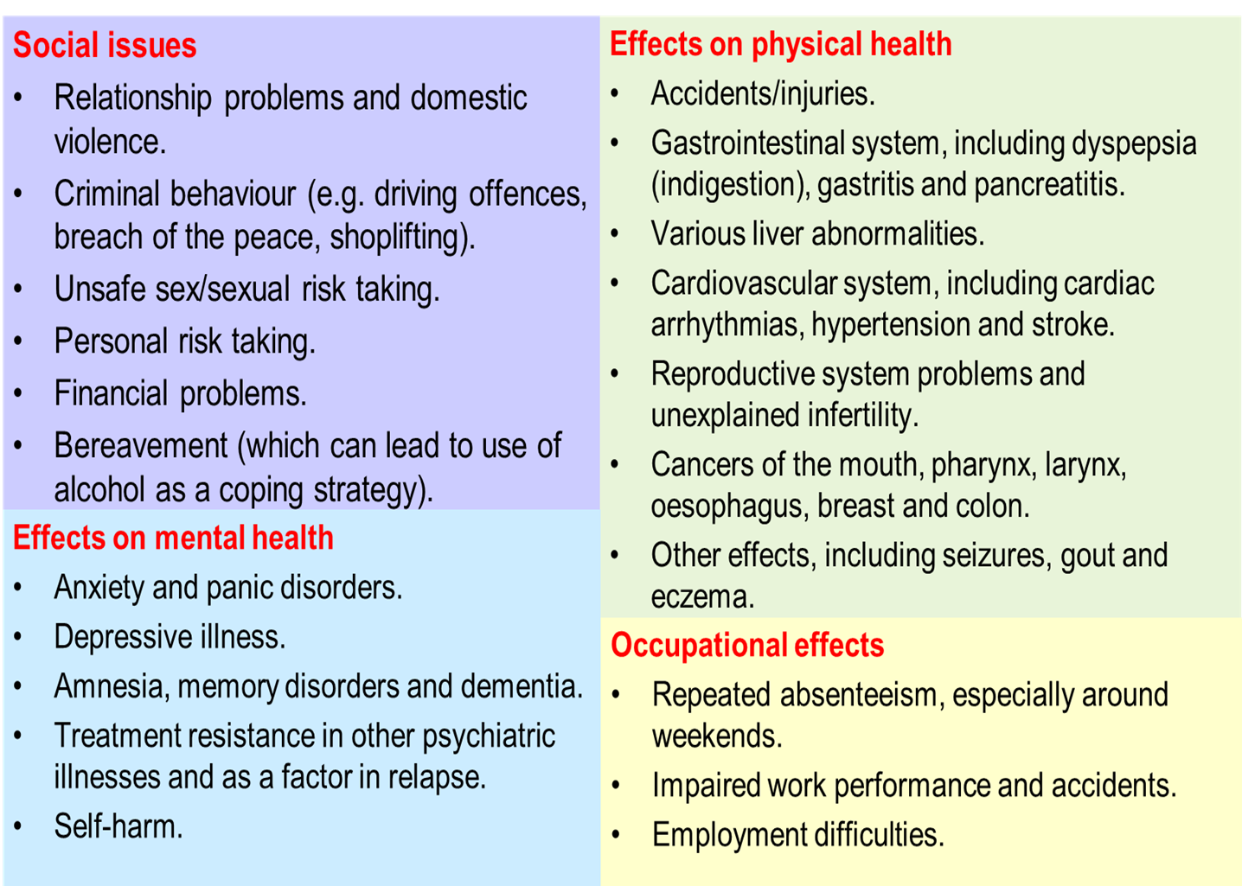

CONVERSATION STARTERS
Gaining Permission:
“Is it okay if we talk about how your drinking might be affecting your health? “
“Would it be okay to discuss…?
Indirect ways to start a healthy chat:
“You mentioned that… you are drinking more often….”
“It sounds like… you might be interested in cutting down…”
“What makes you want to… cut down?”
“How is your drinking affecting your health?”
More direct approaches:
“What do you drink on a night out / at home?”
“What do you like about <alcoholic drink of choice> / how it makes you feel?”
“How often do you drink?”

WHY TALK ABOUT ALCOHOL?
Many people don’t realise they are drinking at harmful or hazardous levels. With the right support, it’s possible to improve health and wellbeing by cutting down drinking or stopping altogether.
Using your skills to speak to someone about alcohol can motivate and support them to change their drinking behaviour. Reducing alcohol consumption can quickly improve physical and mental wellbeing.

HOW TO STRUCTURE A CONVERSATION
- Ask: Be aware of opportunities for change and raise the issue.
- Explore: Use Open Discovery Questions, a non-judgemental attitude; try to avoid 'telling' people what to do.
- Use AUDIT C to support identification of risk alongside the following resources to help support your discussion:
- Alcohol Healthy Conversation Gudiance
- Alcohol Structured Brief Advice Tool
- Act: on the person’s response:
- Share the Rethink your drink resources for helpful tips on cutting down and the NHS Drink Free Days App

- Refer to Inclusion Recovery Hampshire for further support. Anyone can self-refer for support.

