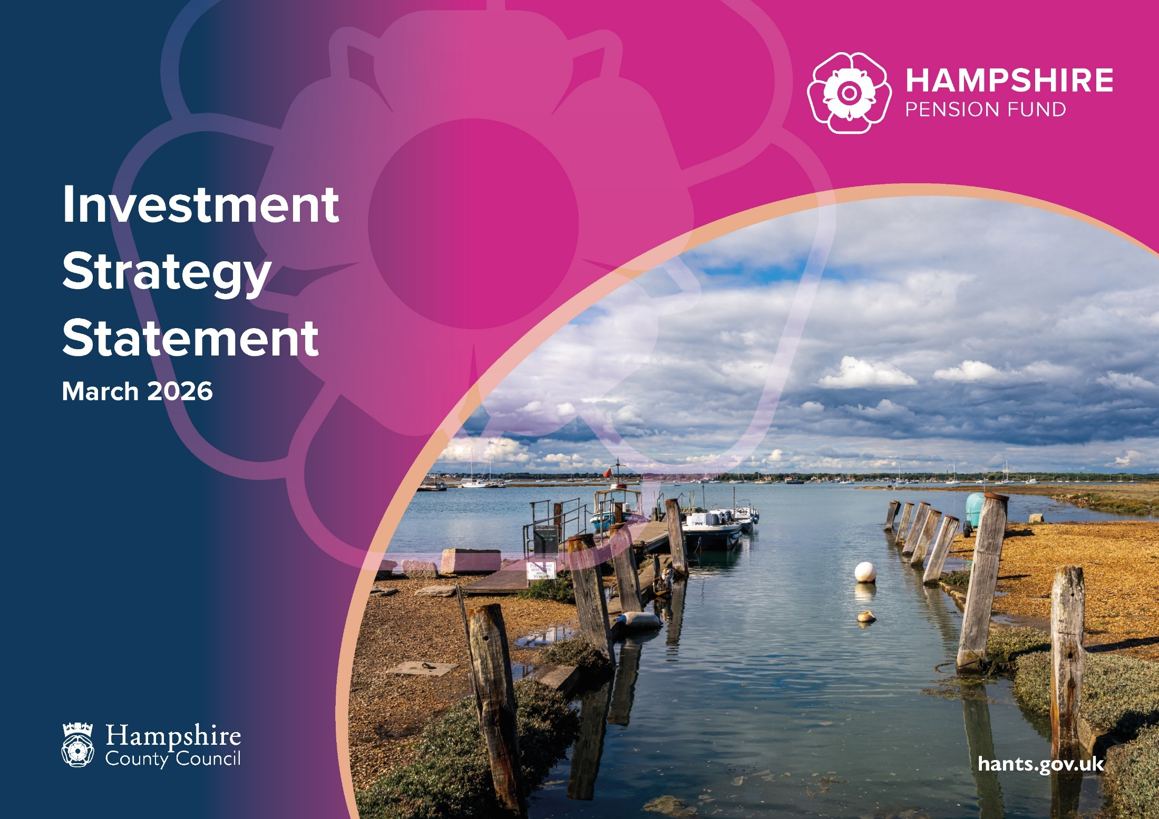
Contents
Introduction 3
Investment strategy 3
Investment objective 3
Investment Beliefs 4
Variety of investments 5
Approach to risk 5
Rebalancing 8
Liquidity 8
Local Investment 8
Approach to pooling 9
Responsible investment policy 11
1. Rationale, definition and beliefs 11
2. Prioritisation of RI issues 12
3. Stock/sector exclusions and social impact investments 13
4. Framework and approach 14
5. Exercise of rights attaching to investments 18
6. Monitoring, reporting and next steps 19
RI standards 20
RI priorities for the coming year 21

Introduction
Hampshire County Council is the administering authority for the Hampshire Pension Fund (the “Fund”), which covers employees of the County Council, two unitary councils, 11 district councils, and 388 other scheduled and admission bodies. The total number of contributors is 61,842 and there are 92,084 deferred scheme members and 58,277 pensioners (all as of 31 March 2025).
The Local Government Pension Scheme (Management and Investment of Funds) Regulations 2016 require pension fund administering authorities to prepare and review, from time to time, an Investment Strategy Statement.
This Statement has been drafted to comply with these regulations in accordance with the Guidance on Preparing and Maintaining an Investment Strategy Statement.

Investment strategy

Investment objective
The Fund has three main aims

- To manage the employers’ liabilities effectively and ensure that sufficient resources are available to meet all liabilities as they fall due.
- To enable primary contribution rates to be kept as nearly constant as possible (subject to the Administering Authority not taking undue risk) at reasonable cost to the taxpayers, scheduled, resolution and admitted bodies. This aim is subject to the Fund achieving and maintaining fund solvency and long-term cost efficiency, assessed in light of the risk profile of the Fund and employers, and the risk appetite of the Administering Authority and employers alike.
- To seek returns on investment within reasonable risk parameters.
In compiling the Fund’s 2025 Actuarial Valuation, the Fund’s Actuary (Hymans Robertson) advised that the Pension Fund requires the assets to deliver a long-term return of above the discount rate of 5.9%, which is set out in the Fund’s Funding Strategy Statement.

Investment Beliefs
The Pension Fund Panel and Board have prepared a set of investment beliefs based on their experience of the workings of the Fund and the nature of the underlying investments held.
Asset class selection:
- Equities are expected to generate superior long-term returns
- Credit offers both a source of diversification and income
- Government bonds provide income, liquidity and a degree of liability matching
- Alternative investments provide diversification and additional return
- Appropriate management of the impact of foreign currency

Implementation:
- Strategic allocations are deliberate long-term targets
- Market inefficiencies require access to a full opportunity set
- There is room for diversification of approach
- Fees and costs matter
- Making positive investment choices
- Cashflow is important

Principles:
- Funding and investment strategy are linked
- Strategic asset allocation is a key determinant of risk and return
- Clear and well-defined objectives are essential to achieve future success
- Responsible Investment (RI) is important to the Pension Fund and can have a material impact on the long-term performance of its investments
- The Pension Fund will take an appropriate level of investment risk
- Long-term investing provides opportunities for enhancing returns
- Decision-making must be evidence based

Variety of investments
In order to achieve the return in its Funding Strategy, the Investment Regulations require the Pension Fund to invest money in a wide variety of investments and state the maximum percentage that it will invest in particular investments or classes of investment.
The strength of the majority of the Fund’s employers’ covenants and the present positive annual cashflows allow the Fund to have set a long-term deficit recovery period and to take a corresponding long-term view of investment strategy.
Suitability of investments and receipt of investment advice
The Pension Fund has access to the necessary skills, expertise and resources to manage the whole Fund. When making investment decisions the Pension Fund Panel and Board has taken advice from appropriate specialist investment professionals including officers, consultants and its independent adviser. The Panel and Board have appointed a permanent independent adviser (currently Investment Trustee and Adviser Ltd) to provide advice on all investment decisions.
The Pension Fund recognises the importance of ensuring that all staff and Panel and Board members charged with the financial management and decision making with regard to the Fund are fully equipped with the knowledge and skills to discharge the duties and responsibilities allocated to them. The members of the Panel and Board annually complete a training needs analysis based on CIPFA’s Knowledge and Skills Framework for pension funds, which includes investments, and a training plan is prepared to meet the requirements identified.
To fulfil the training needs of officers and Panel and Board members the Pension Fund will access training from the most appropriate source. The Panel and Board will review this Investment Strategy Statement from time to time and at least every three years following the actuarial valuation.

Approach to risk
Based on advice from its Actuary, the Fund’s Actuarial Valuation is based on a probability of funding success of 80% - based on the economic modelling of its Actuary, the Fund expects to have an 80% chance of meeting its long-term funding aim, which it considers prudent.
The Pension Fund has identified a number of risks on its risk register that may impact its funding and investment strategies which is reviewed at least annually by the Panel and Board. The Pension Fund maintains a risk register to identity key risks, consider and assess their significance, likelihood of occurrence and potential impact of the risk.
The Panel and Board is aware that the Fund has a need to take risk (e.g. investing in growth assets) to help it achieve its funding objectives. The Fund’s appetite for risk is to minimise the overall portfolio risk while delivering the target returns through a diversified portfolio.
Strategic asset allocation
To implement the Pension Fund’s Investment Strategy the Pension Fund Panel and Board sets a Strategic Asset Allocation with the aim of achieving the Fund’s overall long-term target return without exposing the Fund to excessive risk. In setting the Strategic Asset Allocation advice was commissioned from Hymans Robertson on the options for the Fund’s asset allocation and the most effective allocation for achieving the Fund’s target return with the degree of certainty specified in the Funding Strategy Statement. The Pension Fund considers assets in three main categories:
- Growth - to deliver sufficient return to meet the funding target and maintain the affordability of the target level of contributions.
- Income - structuring the assets to meet the Fund’s income requirements or increase the confidence of achieving required returns through a more stable and observable return stream.
- Protection - employing investment strategies that provide some downside protection or diversification benefit to maintain stability in the level of contributions.
For the purpose of setting maximum limits the Pension Fund has done based on these categories. The total is deliberately greater than 100% to allow flexibility between the categories. The allocation below favours growth assets as the Fund believes that participation in economic growth is a major source of long-term equity returns, which will be required to meet its long-term investment return target and mean that employer contributions can be kept lower.
In line with the Regulations, the Fund’s investment strategy does not permit more than 5% of the total value of all investments of Fund money to be invested in entities which are connected with the County Council within the meaning of section 212 of the Local Government and Public Involvement in Health Act 2007.
At the 2025 valuation 1.2% of the Fund’s liabilities were orphan liabilities. The Administering Authority currently operates a single investment strategy as outlined above. Therefore, orphaned liabilities have been valued on a consistent basis to that of other employers in the Fund who would need to meet any underfunding of these employers.

The following table shows the Strategic Asset Allocation that the Pension Fund has been working towards and the Asset Allocation that has been set under the draft ‘Fit for the Future’ regulations.

 | Asset Allocation |  | Benchmark | Target (net) | 'Fit for the Future' allocation |  | Range
Growth | Active equities | 20.0% | MSCI All Countries | +1/1.5% | Listed equity | 31.0%
Growth | Passive equities | 11.0% | MSCI All Countries
Growth | Private Equity | 7.5% |  | +9-11.5% | Private equity | 7.5%
Growth |  |  |  |  |  |  | 30-60%
Income | Private Debt | 5.0% | 3-month Sonia | +4% | Private credit | 5.0%
Income | Property | 10.0% | RPI | +3.5% | Real estate | 12.5%
Income | Timber | 2.5% |  | +6%
Income | Infrastructure | 10.0% |  | +7.5-10% | Infrastructure | 10.0%
Income | Multi-asset Credit | 10.0% | 3-month Sonia | +3% | Credit | 17.0%
Income | Asset-backed Securities | 2.0% | 3-month Sonia | +2%
Income |  |  |  |  |  |  | 20-50%
Protection | Investment-grade Credit | 5.0% | ICE BoA Euro Sterling | +1%
Protection | Cash | 0.0% |  |  | Cash | 0.0%
Protection | Index-linked Gilts | 14.5% | FTSE index-linked +5 years |  | UK Government Bonds | 17.0%
Protection | Fixed interest Gilts | 2.5% | All Stocks Gilts
Protection | Other | 0.0% |  |  | Other | 0.0%
Protection |  |  |  |  |  |  | 10-30%
Total |  | 100.0% |  |  |  | 100.0%

Rebalancing
In addition to the ranges above, to ensure that the Pension Fund’s investment allocations remain in line with the agreed strategy, the Pension Fund Panel and Board has agreed minimum allocations for specific asset classes to ensure allocations do not drift too far through the natural movement of valuations of different asset classes over time. The following minimum allocations below that been agreed, in addition to the ranges in the asset allocation, would trigger a review and Pension Fund Panel and Board would take advice (in the first instance from LGPS Central - LGPSC) to consider whether the strategic allocation needed to be amended.
Asset class | Strategic allocation | Minimum allocation
Credit | 17% | 13%
UK Government bonds | 17% | 13%

Liquidity
Based on the 2025 Actuarial Valuation, the Pension Fund estimates that its cashflow from dealing with members (contributions received less pension benefits paid) will be a deficit of approximately £70m pa for the three financial years starting in 2026/27. The Pension Fund forecasts this deficit to be more than met from the net income from investments (income less expenses) if the Fund continues to receive income as it is distributed rather than these funds being reinvested.
The Pension Fund aims to maintain a minimum cash buffer of £60m available throughout the valuation period, to account for a higher-than-expected growth in liabilities or unexpected obligations.
The Fund will continue to monitor its cashflow position alongside LGPSC in their management of the Fund’s investments, to ensure that the Fund can continue to meet its obligations.

Local Investment
The Pension Fund supports investment in the local area as a means to achieve the dual aims of providing the necessary investment returns required to pay pensions and supporting the local economy which will be a wider benefit to pension scheme members.
To achieve this the Pension Fund sets a long-term range of 3-5% (8.6-14.3% of the Fund’s allocation to private market portfolios) for local investments. This includes local investments in Hampshire’s current portfolios. The target is sub-divided as follows:
- 1-2% in the Hampshire and the Solent Combined County Authority area.
- 2-3% in the wider LGPSC area (subject to seeing the details of LGPSC’s local investment fund).
The local investment target should be met through the Pension Fund’s strategic allocation to private markets (private equity, private credit, infrastructure and real estate). The Pension Fund expects its target to local investments to be broadly allocated in line with its allocations with private markets (as shown in the chart below) and to achieve the same target returns as other investments in these asset classes, presenting as good or better benefits to the Pension Fund from investing in them.
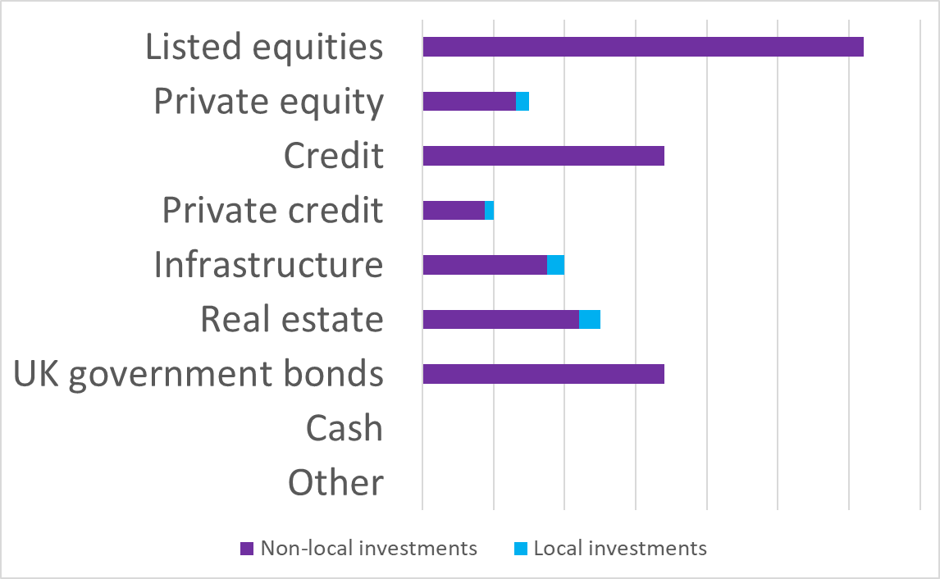
In addition to achieving its target investment return, the Pension Fund recognises the importance of demonstrating the impact of local investments. Given the wide range of potential local investments, there is no single measure of impact, but priority areas of impact will be:
- Supporting the local economy
- Alignment to the Pension Fund’s net-zero target
- Positive social impact
The Pension Fund will continue to report on its local investments including the impact of those investments.
The Pension Fund will review its targets for local investment with the Hampshire and the Solent Combined County Authority (HSCCA) once it is established, and be informed by HSCCA’s Local Growth plan.

Approach to pooling
Hampshire is a member of LGPSC. From 1 April 2026 LGPSC will be responsible for the implementation of this investment strategy and management of the Pension Fund’s investments.
Hampshire will be a member of LGPSC alongside:
Cheshire | Nottinghamshire
Derbyshire | Shropshire
Gloucestershire | Staffordshire
Isle of Wight | Suffolk
Leicestershire | West Midlands
Oxfordshire | Wiltshire
Norfolk | Worcestershire

By law, LGPSC must be authorised by the Financial Conduct Authority to perform relevant regulated investment activities on behalf of the Pension Fund. In addition, the Panel and Board expect any investment managers appointed by LGPSC to be authorised under the Financial Services and Markets Act 2000 to undertake investment business. This Investment Strategy Statement has been shared with LGPSC for their comment.
The Panel and Board expect LGPSC to agree specific benchmarks with each investment manager the Pension Fund’s assets are invested with so that, in aggregate, they are consistent with the overall asset allocation for the Fund. The Fund’s investment managers will be expected to hold a mix of investments which reflects their views relative to their respective benchmarks. Within each major market and asset class, the investment managers will be expected to maintain diversified portfolios through direct investment or pooled vehicles. Investment managers of index-tracking funds in which the Fund’s assets are invested in are expected to hold a mix of investments within each pooled fund that reflects that of their respective benchmark indices.
The Panel and Board and LGPSC have agreed that the Pool will report quarterly on how investment managers and LGPSC investment products are performing in relation to the targets and expectations set for them.

Responsible investment policy

1. Rationale, definition and beliefs
- Environmental: climate change, including physical risk and transition risk, resource depletion, including water, waste and pollution, deforestation
- Social: working conditions, including slavery and child labour, local communities, including indigenous communities, conflict, health and safety (including health inequalities), employee relations and diversity
- Governance: executive pay, bribery and corruption, political or religious lobbying and donations, board diversity and structure, unjustifiable tax strategy

The Pension Fund’s investment principles include:
- a long-term focus to make investment returns to meet pensions liabilities, i.e. the amount needed to fund retirees (currently calculated by the Fund’s actuary as 4.4%pa), and
- a belief in the importance of Responsible Investment (RI), including consideration of social, environmental and corporate governance (ESG) factors, which can both positively and negatively influence investment returns.
Therefore, RI is important to the Pension Fund in fulfilling its role to pay scheme members benefits and for its reputation with scheme members, employers and the wider Hampshire community. This document sets out how the Fund’s RI responsibilities are delivered in line with these principles.
The Pension Fund’s approach to RI, includes consideration of the Principles for Responsible Investment (PRI), a set of six principles that provide a global standard for responsible investing. The PRI sets out the following examples as guidance:
This policy is based on the following key RI beliefs:
- RI considerations are important, particularly over the longer term to both protect and enhance long-term investment return and maintain alignment to stakeholders’ values
- RI considerations apply to all asset classes, but different asset classes may mean the management and implementation is different
- Responsible management of RI Issues is a reputationally important issue for the Pension Fund
- The Pension Fund expects the consideration of ESG factors to be incorporated into the portfolio construction process of all investments made by our investment managers

2. Prioritisation of RI issues
The Pension Fund believes all of the issues highlighted as ESG factors above are important and need to be appropriately managed. Hampshire has aligned its RI priorities to those of the ACCESS pool in order to maximise both its impact in achieving these priorities and reporting to scheme members and employers. Having RI priorities does not diminish the importance of issues that are not mentioned or does not mean that these will not receive attention, but Hampshire is following best practice in setting priorities to give focus to its ESG work.
Environmental factors
Climate change
Climate change risk is aligned with the Task Force on Climate-related Financial Disclosures recommendations, which covers:
- climate governance,
- strategy,
- risk management and
- metrics and targets.
Areas of focus within climate change include:
- transition risks (shifting business models to being net zero),
- physical risks (impact of climate change on business operations)
- a focus on renewable energy.
Just transition
Hampshire seeks a “just transition to a low carbon economy that ensures fair treatment for employees and communities that would otherwise bear the brunt of industrial change.”
Social factors
Human rights, including
- modern slavery,
- child labour and
- treatment of local communities.
Labour practices, including
- good employment relations,
- health and safety at work,
- human capital management and
- training.
Governance
Good governance
Aligned with the UK Corporate Governance Code, which notes that effective and entrepreneurial leadership is critical to the long-term success of a company and sustainable returns for investors.
Good governance covers:
- appropriate board structure to ensure internal controls and challenge,
- diverse board membership to avoid groupthink,
- the skills mix required for a board to be effective and
- adequate director independence to protect the interests of minority shareholders (such as pension funds in public equities).
Part of good governance is also ensuring executive remuneration is not excessive, supports the long-term success of the company, rewards performance and is aligned with the interests of shareholders.

3. Investing for positive impact
The Pension Fund recognises the potential for investments to achieve positive environmental and social benefits as well as achieve the financial returns it requires to pay pensions. This is particularly true for the Fund’s allocation to private market investments; private equity, private debt, infrastructure and real estate (including timberland), which makes up 35% of the Fund’s asset allocation.
The Pension Fund aims for a third of this allocation (just over 11.5% of the Fund’s total asset allocation) to private markets to be invested in investments with positive impacts, whilst continuing to achieve the investment return targets that the Fund has set. The Fund defines investments with positive impacts classified as SFDR Article 8 or 9 or their equivalent.
The Pension Fund will work with LGPSC to monitor and report on investments with positive impacts.

4. Stock/sector exclusions and social impact investments
The Pension Fund’s current policy is to engage with companies to promote and encourage them to achieve better RI outcomes, and would want to continue to engage rather than disinvest, where a company/sector is progressing towards better management of RI issues. However, after thorough consideration the Pension Fund Panel and Board (PFPB) have agreed to actively work towards disinvesting from fossil fuel investments.
The Pension Fund’s focus remains on measuring and reducing the carbon footprint of all the companies in which it invests and working with its investment managers to find ways to reduce the overall carbon footprint in line with its aim to have net-zero emissions by 2050, whilst continuing to achieve the investment returns that are required to pay pensions.
The Fund will continue to consider further disinvestment or exclusion of a particular sectors or investment in specific ‘social’ investments where the management of ESG issues, including making a positive contribution to a lower carbon economy, in cases where they are not considered to be well managed, with no scope for improvement. The Pension Fund will act if it believes that the decision would be supported by a significant majority of scheme members and employers; the Fund may take this approach so long as it does not result in significant financial detriment to the Pension Fund.

5. Framework and approach
Consideration of ESG in investment decisions
The Pension Fund delegates its investment decisions to its current and future appointed investment managers, who are a combination of specialist external active investment managers and passive investment managers. The PFPB engages in responsible stewardship with its investment managers and will review and monitor investments based on the following model:

- Challenge – where the underlying investment/company delivers less than a net neutral contribution to a sustainable society with a high barrier to transformation, the Fund will challenge its investment manager (where appropriate) on their decision to hold the investment.
- Neutral – underlying investments/companies that have potential to transform their operations and/or business model to fit in a sustainable future.
- Embrace – where underlying investments/ companies are delivering a positive contribution with an undebatable fit in a sustainable future, the Fund will be in dialogue with its investment managers to understand what it can learn from these investments and its investment managers’ decisions to invest.
- Engagement – in all situations the Fund expects its investment managers to engage with companies that they have invested in, as described in more detail below.
The Fund recognises that there are different expectations for its investment managers in the context of this Policy as follows:
Passive investment managers
These managers are employed to mirror the stocks in various indices, and the PFPB accept that in making investments for the Pension Fund through an index, passive managers are unable to actively take ESG factors into account.
However, the PFPB does expect its passive investment managers to act in the best interests of the Pension Fund to enhance the long-term value of investments and support and encourage sound practices in the boardroom. As such the PFPB expects its passive investment managers to engage with companies within the index on areas of concern related to ESG issues and to also exercise voting rights particularly with regard to ESG factors, in a manner that will most favourably impact the economic value of the investments (see separate section below on Exercising Voting rights).
Quantitative investment managers
These investment managers employ automated techniques to select stocks as opposed to individual judgement (used by ‘traditional’ active investment managers), but unlike passive investments are not constrained by any index. The Pension Fund would only utilise a quantitative investment manager if having taken advice it was appropriate for implementing the Fund’s investment strategy and following a thorough assessment of the investment manager and their quantitative model, including the extent to which it can account for ESG factors.
Similar to passive investment management the Pension Fund accepts that a quantitative investment manager cannot make stock specific judgements on ESG issues and therefore may not be able to take all ESG factors into account in their investment decisions. However, the Fund still requires the same level of engagement and exercise of voting rights (as described above) as with all other investment managers.
Active investment managers
The PFPB delegates responsibility for making individual investment decisions (non-passive) to its active investment managers. All the Pension Fund’s active equity and fixed income managers are invested in via the ACCESS pool. Investment managers in the ACCESS pool are subject to ACCESS’s RI guidelines, which accord with Hampshire’s policy requiring its active investment managers to pro-actively consider how all relevant factors, including ESG factors, will influence the long-term value of each investment.
Investments are expected to transfer to LGPSC’s management from 1 April 2026, and will be subject to LGPSC’s RI policy, which, as shareholder and client, Hampshire will be able to feed back on.
To ensure ESG factors are considered in investment decisions, the PFPB uses the following framework of questions, which it requires its investment managers to be able to answer and uses these as a basis to scrutinise them.
For each investment, has the investment manager assessed and concluded that the overall expected long-term financial return is mitigated from the risk of:
- the physical shock of climate change (including damage from extreme weather events), together with the impacts of transitioning to a lower-carbon economy;
- negatively contributing to climate change or other environmental issues, such as pollution, waste (including use of plastics) and bio-diversity loss;
- any outcome damaging to human rights, including slavery and child labour in supply chains, and the impact of armaments, particularly controversial weapons (namely cluster bombs, landmines, depleted uranium weapons, and chemical and biological weapons);
- detrimental social impacts or increasing health inequalities from the company’s products/services, such as tobacco;
- poor corporate governance, systems of control and lack of transparency;
- a senior management pay structure biased towards managers making short-term decisions not in the company’ and investors’ long-term interests;
- the detrimental treatment of the company’s workforce or workers in the supply chain on issues such as health and safety, gender equality and pay;
- dangerous business strategies, such as the creation of monopolies, that may expose the company or wider economy to unacceptable risk;
- reputational damage to the company, the Pension Fund in relation to its beneficiaries, Hampshire residents, or the general principles of the UK Corporate Governance Code; as a result of its approach to any ESG issue.
If the PFPB do not receive satisfactory responses to these questions they may undertake further engagement with investment managers (and possibly directly with investments) and/or consider directing the investment manager to not invest in the company/sector in question.
Closed-ended limited partnerships
The Pension Fund invests in closed ended limited partnerships and has let a number of discretionary contracts to investment managers for investments in private equity and infrastructure in these types of investments. The Pension Fund requires that its investment managers integrate ESG considerations into their selection of these investments, which it believes will improve the long-term risk adjusted returns. Whilst the Pension Fund expects its investment managers to be able to influence the investment decisions of these partnerships, it accepts that once the Fund has committed its investment it cannot control the underlying investments that are made.
Direct property
The Pension Fund has made a strategic allocation to invest in UK commercial property, and therefore recognises that as a landlord it has an opportunity to affect the quality of the buildings it owns. As part of the investment management contract the Pension Fund has let for the discretionary management of its property portfolio, the Pension Fund expects its investment manager to consider improving the environmental impact of each of the properties it owns as part of the investment case for owning each property.
Responsible investment sub-committee
The Pension Fund Panel and Board (PFPB) take their responsibilities for Responsible Investing and the consideration of ESG issues very seriously, and have established a Responsible Investment sub-committee, which meets at least twice a year, to review ESG issues and support implementation of the Responsible Investment Policy.
The Terms of Reference of the sub-committee are as follows:
To make recommendations to the PFPB on ESG issues having completed the following activities.
- To review regularly the Pension Fund’s Responsible Investment Policy (contained in its Investment Strategy Statement), and practices relating to it, to ensure ESG issues are adequately reflected.
- To provide a forum for considering representations to change this Policy and/or the Pension Fund’s responsible investment practices relating to it.
- To engage in responsible stewardship with its investment managers and to provide a forum for the review and monitoring of investments in the context of the Policy.
- To receive any relevant training on ESG issues.
- To review investment managers’ company engagement and voting decisions and when necessary, engage directly and indirectly with investment managers (where possible directly with companies the Pension Fund is invested in) to make representations concerning ESG as appropriate.
- To engage directly and indirectly with scheme members and employers to hear representations concerning ESG as appropriate.
- To report annually on the Pension Fund's Responsible Investment activities to demonstrate progress to the Pension Fund's stakeholders.
Conflicts of interest
Conflicts of interest in relation to responsible investment and stewardship could arise when the ability to represent the interests of the Fund as a shareholder is hindered by other interests. These can arise within the Fund or within external service providers.
The Pension Fund expects investment managers it employs to have effective policies addressing potential conflicts of interest, and that these are all publicly available on their respective websites. These are discussed prior to the appointment of a manager and reviewed as part of the standard manager monitoring process.
In respect of conflicts of interest within the Fund, PFPB members are required to make declarations of interest prior to meetings which are documented in the minutes of each meeting and available on the County Council’s website at https://www.hants.gov.uk/. Hampshire County Council, as the Administering Authority of the Hampshire Pension Fund, requires all members of the PFPB and officers to declare any pecuniary or other registerable interests, including any that may affect stewardship of the Fund’s investments. Details of the declared interests of County Council members are maintained and monitored on a Register of Member Interests. These are published on the County Council’s website under each member’s name and updated on a regular basis.

6. Exercise of rights attaching to investments
Each of the Pension Fund’s investment managers is asked to work in a consistent and transparent manner with companies they are invested in to ensure they achieve the best possible outcomes for the Pension Fund, including forward-looking ESG standards. This includes requiring investment managers to exercise the Fund’s responsibility to vote on company resolutions wherever possible.
The Fund believes that if companies comply with the principles of the UK Corporate Governance Code published by the Financial Reporting Council, this can be an important factor in helping them succeed; but the Fund also accepts the need for a flexible approach that is in the common long-term interests of stakeholders including shareholders, company employees and consumers. The Fund’s investment managers should cast their votes with this in mind.
In particular, the Fund’s investment managers should cast their votes to ensure that:
- executive directors are subject to re-election at least annually;
- executive directors’ salaries are set by a remuneration committee consisting of a majority of independent non-executive directors, who should make independent reports to shareholders;
- arrangements for external audit are under the control of an audit committee consisting of a majority of independent non-executive directors, with clear terms of reference; these should include a duty to ensure investment managers closely control the level of non-audit work given to auditors, and should not significantly exceed their audit-related fee unless there are, in any investment manager’s opinion, special circumstances to justify it;
- in the investment managers’ opinion, no embarrassment is caused to the Fund in relation to its beneficiaries, Hampshire residents, or the general principles of the UK Corporate Governance Code.
The Pension Fund’s equities are available for Stock Lending, via the programme agreed as part of the ACCESS pool. The programme includes the provision for investment managers to recall stocks from the lending programme, should this be necessary voting at company meetings.

7. Monitoring, reporting and next steps
Reporting
Scheme members were consulted on the original version of this RI policy in 2019. Any comments on ESG issues are reported to the RI sub-committee as a standing item at each meeting.
The Pension Fund’s investment managers (both active and passive) are required to report to the Pension Fund on their engagement with company management and voting recording, highlighting any instances that they voted against company management or did not follow these guidelines.
The reports of the investment managers on their consideration of ESG factors, their company engagement and collective engagement and shareholder voting will be viewed by the Pension Fund’s officers, the Responsible Investment Sub-Committee and Pension Fund Panel and Board.
The following table shows how the Pension Fund sets its policy and reviews its progress including complying with the various standards it has adopted.

 | Frequency | Where to find it
Strategies and policies
Investment Strategy Statement | Reviewed annually | Pension Fund Policies
Responsible Investment Policy | Reviewed annually | Responsible Investments
External Reports
Annual Report and Annual RI Update | Annual | Annual reports and accounts
TCFD Report | Annual | Responsible Investments
UK Stewardship Code Report | Annual | Responsible Investments
PRI report | Annual | Responsible Investments
GRESB report | Annual | Reported to Panel and Board

Internal reports
Stewardship report to the RI sub-committee | Bi-annual | Committee details - Hampshire Pension Fund Responsible Investment Sub-Committee
Investment manager voting reports | Quarterly | Responsible Investments

RI standards
The Pension Fund supports and/or is a member of the following initiatives that aim promote RI for investors and positive changes in management of ESG factors:
- UK Stewardship Code 2020 – The Pension Fund has been accepted as a signatory of the 2020 Code (one of only six initial LGPS signatories), which sets high stewardship standards for those investing money on behalf of UK savers and pensioners. The Fund has produced a Stewardship Code statement that sets out on a ‘apply or explain’ basis how it meets the 12 principles of the Code. Statement of compliance - UK Stewardship Code 2020
- Principles of Responsible Investment (PRI) – The Fund is a signatory to the PRI, which was founded by the United Nations and is the world’s leading proponent of responsible investment. In becoming a signatory the Pension Fund has committed to the PRI’s six principles for RI. More information can be found here: Principles for Responsible Investment | PRI
- Pensions for Purpose - The Fund is a member of Pensions for Purpose. Pensions for Purpose engages with pension funds and other institutional investors towards embracing impact investing. As a member the Fund has access to Pensions for Purpose services and member forums, where we will benefit from resources to guide the approach to impact investing. More information can be found here: Pensions For Purpose
- Taskforce on Climate-Related Financial Disclosure (TCFD) – the Pension Fund supports TCFD which aims to develop recommendations for more effective climate-related disclosures that could promote more informed investment decisions and, in turn, enable stakeholders to better understand the concentrations of carbon-related assets in the financial sector and the financial system’s exposures to climate-related risks. The Pension Fund reports in line with recommendations of TCFD. TCFD Report
- Institutional Investors Group on Climate Change (IIGCC) – The Fund is a member of the IIGCC. The Fund has made a public net zero commitment. As part of its membership the Fund benefits from educational materials, webinars, and the net zero framework, which will help the Fund achieve the target of net zero by 2050. More information can be found here: IIGCC - The Institutional Investors Group on Climate Change

RI priorities for the coming year
The following topics have been identified as specific priorities for the coming year:
- To increase reporting to scheme members on RI, to reflect the significant increase in scheme member engagement in the 2025 RI survey
- To work with the Fund’s investment managers to identify where the labour practices and supply chain management of companies the Pension Fund invests in have the greatest risk of slavery or child labour
- To continue to work towards disinvesting from fossil fuels
- To work with LGPSC to ensure the Pension Fund's RI priorities (namely climate change, and the prevention of slavery and child labour) are embedded in their approach to RI and engagement activity
- Transition Pathway Initiative (TPI) – The Fund publicly supports TPI, which is a global, asset-owner led initiative which assesses companies’ preparedness for the transition to a low carbon economy. The TPI tool assesses progress against companies and sectors to measure the level of management quality and carbon performance, to aid in risk assessment. More information can be found here: Home - Transition Pathway Initiative
- Just Transition – A “just transition” means not transitioning to a low carbon economy at any cost but doing so whilst also ensuring that this is done in a socially responsible way. The Grantham Research Institute on Climate Change and the Environment at the London School of Economics and Political Science have put together a comprehensive guide as to what this means for investors, and what action can be taken. The Fund has signed a statement of support and uses the guide to help embed this goal within the Fund’s policies and help hold our investment managers to account. More information is available at the following link: Investing in a just transition - global project - Grantham Research Institute on climate change and the environment
The Pension Fund will consider signing up to other investor standards and initiatives where the Pension Fund Panel and Board believes it will enhance Hampshire’s RI policy.

Hampshire Pension Fund
The Castle,
Winchester,
Hampshire
SO23 8UB.

