
Supported Accommodation Market Position Statement

Version May 2025
This market position statement specifically addresses the commissioning of supported accommodation.

Legal landscape

In addition to the key documents referred to in the Strategic Commissioning Service’s overarching market position statement, which provide a framework for all commissioning activity that the service undertakes on behalf of Children’s Services, this statement gives due consideration to the following regulations and guidance in working with the supported accommodation sector:

The Supported Accommodation Regulations (England) 2023:
The Supported Accommodation (England) Regulations 2023 (legislation.gov.uk).

The statutory guidance accompanying the regulations on providing supported accommodation for children and young people: Guide to the supported accommodation regulations including quality standards (publishing.service.gov.uk).The guide includes the quality standards that all supported accommodation providers must meet.

The Stable Homes Build on Love Strategy specifically led to the introduction of the national standards and Ofsted registration and inspection for supported accommodation for Looked After Children and care leavers aged 16 and 17 years.

The regulations are set around four quality standards:

- Leadership and management: the registered person enables, inspires and leads a culture in relation to the supported accommodation undertaking that puts children first and prioritises their wellbeing and development.
- Protection: children are enabled to feel safe and that their needs are met.
- Accommodation: children experience a comfortable and secure living environment.
- Support: children receive individual and tailored support that meets their needs.

Ofsted: Ofsted’s regulations for supported accommodation, requiring registration and inspection, started on April 2023. Registration became mandatory from October 2023. Ofsted began inspecting registered providers in September 2024. The Guide to the supported accommodation regulations including quality standards explains and supplements the regulations, provides explanations of terms used and sets out what is expected to meet the various requirements of the regulations.

Legal landscape

Placement Demand – Supported Accommodation placements

- Over the last two years, the proportion of post-16 provision has increased at a faster rate than the overall population of Looked After Children, including separated children.
- Pressure is increasing on post-16 accommodation (provisions).

- The proportion of unaccompanied and separated children in supported accommodation placements decreased between September 2024 and February 2025 – from 49% to 43%. This shift reflects a seasonal reduction in the number of unaccompanied children seeking asylum over the winter period.

- Hampshire County Council actively wants to keep all its children, including its unaccompanied and separated children, in Hampshire where possible.

Our commissioned supported accommodation services

The Strategic Commissioning Service commissions and manages a range of contracts and frameworks to secure market access for supported accommodation placements. The aim of supported accommodation is to support our young people to move towards independent living as they approach adulthood.

Support is commissioned at different levels, recognising that young people’s needs will vary, and that they may step through different levels of support within supported accommodation, as their skills and independence grow.

A summary of what we currently commission includes:
- High support needs: This is tailored accommodation and support is for children that need higher levels of support at point of placement, with the aim to move them towards lower levels of support in preparation for independent living.

We commission placements through providers on our open framework. Providers can come forward once a year in October and request to join the framework or update their settings on the framework. The details will be advertised through In-Tend. The current framework runs until 31/03/2026 with the option to extend the framework by up to two years.

- High intensity support: This is an intermediary level of support of around 15 hours per week for young people in multi-occupancy settings. High intensity placements aim to move our young people towards reduced levels of support, such as supported lodgings or low lodgings.

High intensity support is commissioned through a block contract. The current contract runs until 30/06/2025. A procurement process has recently been completed with the contract commencing 1 July 2025 for an initial period of five years.

- Supported lodgings: This is either a low level (2-15 hours a week) or no additional support, placement in a family/host home, with the aim to move the young person towards independent living.

- Emergency beds (e-bed): These provide same day access to a short-term (15 working days) accommodation in a host’s home. As part of accessing an e-bed the young person will undertake a needs assessment to identify whether they can transition to supported lodgings. If their needs are higher, they will be placed in an alternative provision sourced through our other contracts and frameworks detailed above.

E-beds and supported lodgings contract ends April 2027.

You can find details of all our current tenders and live contracts on the County Council’s e-tendering portal, In-Tend.

Whilst we always prioritise using our contracted and framework providers, due to specific needs or shortages, we sometimes need to spot purchase supported accommodation placements.

You can see the breakdown of our placement referrals in the bar chart below, including where we have needed to make spot purchases, which tends to increase in line with overall demand rises.

A breakdown of referrals across the different placement options within supported accommodation

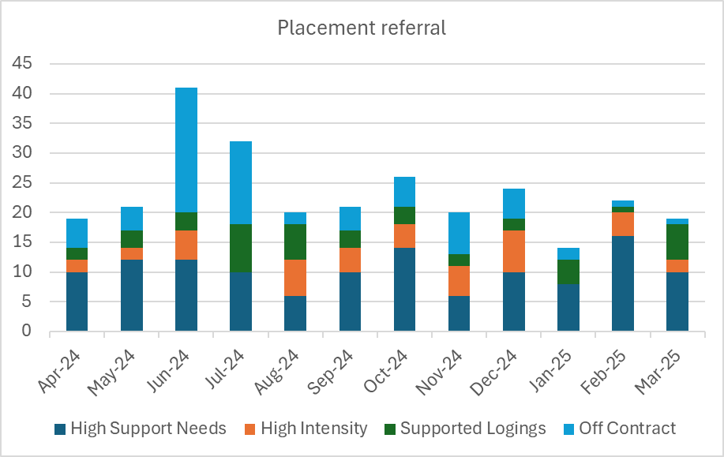

Commissioned capacity
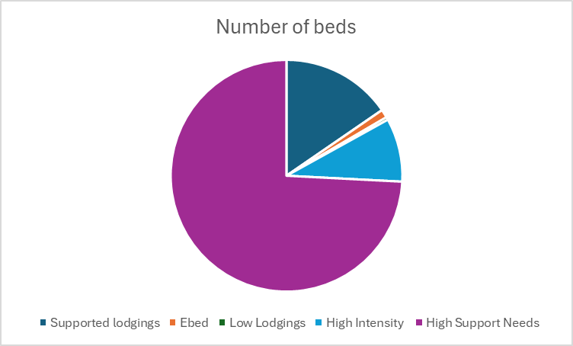

- Around 70% of our placements are contracted with long-term service providers, either through block contracts or providers on our open framework.
- A smaller proportion of placements are contracted through ad-hoc spot purchases where we are seeking to match particular needs and/or location requirements and cannot secure them from our contracted providers at that time.
- The Hampshire market has a good level of provisions locally, meeting our overall demand well.
- We have a high volume of provisions in an open framework and welcome new provisions, especially to support Hampshire’s growing cohort of separated children and to accommodate them within Hampshire.

If you are interested in any of our contractual arrangements, or if you want to receive referrals for our spot purchasing, please send details of your provision to our Senior Category Manager – Supported Accommodation by email to CategoryManagement@hants.gov.uk and/or by completing the following form: Service Provider Contact Form.

Key challenges we face

There are specific issues within the sector that we are looking to you, as an external provider of supported accommodation, to help us to address.

Capacity: Limited capacity in our contracted high intensity and supported lodgings provisions, means we rely too heavily on our high support needs framework. Consequently, there is potential for the County Council to over-commission support compared to what is needed by a young person, simply to secure them a placement.
We need to work collaboratively with providers to create more lower-level capacity so that we can commission placements that best meet young people’s needs and best support them towards independence.

We also need to have options to step young people down from high intensity support to lower-level support, as part of a holistic pathway.

Separated children: This cohort is growing as a proportion of our overall number of young people in supported accommodation. Therefore, we need an increasing number of provisions that can cater for the specific needs of this group of young people.

Cost pressures: Cost of living and inflationary pressures have impacted the cost of supported accommodation whilst local government funding has been on a downward trajectory. We are seeking sustainable long-term relationships with our suppliers, where volume/demand certainty over extended periods means that we can secure better pricing because our providers do not need to price in risk.

Pathways to independence: We have encountered difficulties in transitioning young people from high support needs to lower levels of support. We are keen to work with providers who understand that it is in a young person’s best interests for their independence skills to be developed and support stepped down in line with this, to promote a successful transition to independent living as they enter adulthood. Our placement demand means we can be confident that we will fill vacancies with new young people, but we are most keen to partner with providers who actively promote and support young people to step down within supported accommodation provisions over a period.

Supported lodgings: We are keen to see increases in our placements in supported lodgings, recognising that this has been an underutilised area of supported accommodation. We are keen to hear from providers with this type of provision available.

Complex needs: In line with changes, we are seeing in the cohort of young people coming into care overall, young people requiring supported accommodation are increasingly likely to have some mental health issues. We recognise that this can put pressure on key workers and hosts to deliver sustainable support to meet these needs, and we are keen to hear from providers about the types of support and training they make available to facilitate this.

Overall, the variety of needs, background and particular requirements we are seeing in our young people will impact our commissioning strategy. We are looking to work with providers who recognise these diverse and changing needs, and who are actively developing their services and their staff to support and be responsive to them in an agile way.

How to get involved

We have shared with you our key challenges and some initial thinking around how we might work with you to address these issues. To recap, our current supported accommodation strategic priorities and areas of focus are:
- Better understanding the changing needs of young people, particularly those of Unaccompanied Asylum-Seeking Children (UASC), young people with complex needs and those with mental health needs.
- Developing a more dynamic commissioning approach with service providers to adapt more quickly to our young people needs, backgrounds and wishes.
- Develop stronger channels for us to hear the voice of the child/young person in our commissioning and in terms of your service delivery, for example evidence of how your services also seek out and respond to young people’s needs as they articulate them.
- Improved matching of accommodation and support, and more clearly defined pathways, to enable our young people to move through different levels of provision, best preparing them for independence.
- Revisiting our category strategy to focus on the areas and placement types that are either in greatest demand or shortest supply.
- Ensuring all our provisions deliver best value for money.

Supplier relationships

We want to maintain our longstanding supplier relationships and build relationships with new local suppliers, so that we can work together to best meet the supported accommodation requirements for Hampshire’s young people. To this end we are looking for providers who:

- Are proactive in supporting children to gain independent living skills and who actively move them to lower levels of support and/or exiting supported accommodation services in a planned manner.
- Seek out and incorporate service users’ feedback to improve services, respond to needs and to reduce the risk of placement breakdown. Providers should be able to demonstrate both how they achieve this and the positive impacts of doing so.
- Are happy to share their cost models and explore them with us in a transparent way, to provide assurance of value for money.
- Collaborate with us so that the services we commission can be agile and responsive to children’s changing needs, within the framework of sustained partnership working.

Your agency has a crucial role to play…

- Have questions, ideas, want to talk?
- Get in touch/request a call back: CategoryManagement@hants.gov.uk.

- Have feedback on this market position statement?
  - Email CategoryManagement@hants.gov.uk.

- Want to know more?
- Like to read more? See our Children’s Services Sufficiency Duty Strategy and Children and Young People’s Plan which set out how we aim to meet our sufficiency duties and our priorities for the coming years.

