Shared Lives My permission to share




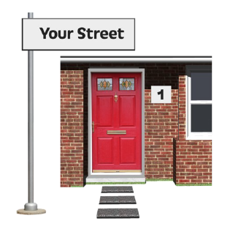
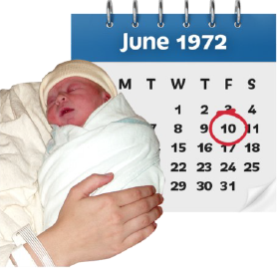


Name

Date born:

Address and post code:

Telephone:

Email:

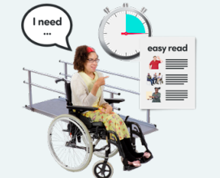
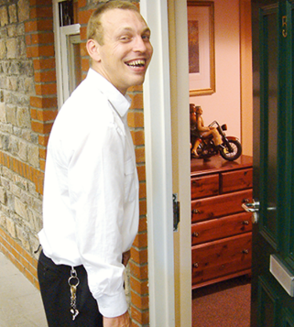

Are you happy to share information regarding your care and support needs with other Shared Lives carers such as your All About Me and any other relevant information.
During your placement you may stay with another Shared Lives carer



I am happy for my care and support information to be shared with other Shared Lives carers in order to provide me with the support I need

Yes

No

Your consent



Please see overleaf for sharing information with external companies.



You may also go on holidays during your time in Shared Lives




You may also attend clubs and activities.

Are you happy to share information regarding your care and support needs with external companies involved with your holidays and activities, such as your All About Me and any other relevant information.

Your consent
I am happy for my care and support information to be shared with external companies such as a holiday provider, insurance companies or clubs, involved with my holidays, clubs and activities

Yes

No

Changing your mind

You can change your mind at any time about someone seeing your information.

To do this you can call us on:

01329 316861



Or email us:

SharedLivesTeam@hants.gov.uk

Date: |  | My permission to share (easy read)
Effective date: |  | 28/02/2026
Review date: |  | 28/02/2027
Author: |  | Helen Bradshaw/ Carers group
Authority to vary: |  | HCC Care and Support Services Senior Management Team
Policies/procedures cancelled or amended:
Amendment: |  |  | Date:
Table with breakdown added |  |  | 28/02/2026

