PEP Report for the November 2023 Virtual Independent Living Conference and the Next Steps

Introduction

2023 marked the 40 year anniversary of the first opportunity for Independent Living for Disabled People in Hampshire. PEP felt that this milestone should be celebrated in some way. In addition, John Evans OBE, one of the original disabled people who convinced Hampshire County Council to begin an Independent Living Scheme (SOCS) forty years ago, is a current PEP Member. SOCS developed into the current day Direct Payment Scheme, which is now protected under national legislation.

A subgroup of PEP was formed and decided to put on a one day virtual conference.

The Conference objectives were:

- To develop, organise and run the conference in co-production with Hampshire County Council’s Adults’ Health and Care Department (AHC) and the Hampshire ICB
- To celebrate 40 years of Independent Living for disabled people in the county
- To look at the challenges and areas of improvement for the Independent Living and Direct Payment Schemes in the future
- To bring together, people who use services with people who provide and plan services

A steering group of PEP Members, AHC staff and ICB staff was formed to develop, organise and manage the Conference which was agreed to be held on Thursday 16th November 2023, the first day of Disability History Month. The group met monthly and agreed workshops were organised in coproduction.

The Conference
On 16th November the conference was held for free between 10.30am -4.30pm on Microsoft teams.

Keynote Speakers
During the Welcome to the Independent Living Conference section, there were 3 keynote speakers:
- John Evans OBE, a Disability Rights Consultant and one of the group of disabled people who got Hampshire County Council to start an Independent Living Scheme 40 years ago. John talked about that process.
- Graham Allen, Director of Hampshire Adults Health and Care, who talked about Independent Living within Hampshire from a Local Authority perspective.
- Anna Severwright, Co-Convener, Social Care Future, who gave an opinion on how Independent Living might look in the future.

Independent Living Conference Workshops

Health and Wellbeing Workshop – Discussed current health and wellbeing inequalities of disabled people within Hampshire, with representatives of the ICB and Public Health. The topics covered included: health screening access for wheelchair users and those with severe mobility impairments, access to GP services for people with verbal/non-verbal and/or sensory impairments, and access to good dietary and exercise services. There was also a discussion on Population Health, Prevention, and the need to further embed co-production into developments in the Integrated Care System.

Housing Workshop
Presentations the about extra care offer from AHC in younger adults and older adults. Also there were presentations from district and borough councils about how to get on the housing list and how the process works and also how the disability facilities ground is applied for and the process for that. After that the panel took questions from the audience.

Transport Workshop
The workshop was facilitated by Ann Frye, an international specialist on the transport needs of disabled and older people. The panel included the head of policy for First Bus, a senior manager from Stage Coach, general manager of Bluestar & Unilink and South western Railway’s accessibility manager and Jim Morey, a Hampshire resident, former transport engineer and access auditor with a visual impairment and Andrew Wilson strategic transport manager (Public transport) at HCC. The panel took questions.

Peer Support Workshop
Peter Beresford OBE Chair of Shaping Our Lives and university academic, writer researcher and activist introduced the session and was joined by Ian Loynes, CEO of Spectrum Centre for Independent Living and John Evans OBE in discussion with those present on issues covering funding, history, value and he future.

Inclusive, Employment and Education Workshop
The workshop focused on apprenticeships and giving young people the skills and opportunities to get into work with contributions from children’s service’s, the Minsted Trust and a young person who following a successful placement has secured a permanent position. It was opened up to questions.

Personal Assistants Workshop
Jade Hamnett, Chair of Independent Living Group facilitated the session. The panel then took questions.
- Michael Grimmett, long standing PA employer and working for Spectrum Centre for Independent Living in support and advice to other DP users
- Topaz, a personal assistant for two people with very different needs and lives
- Dave Humphries, a carer, running a DP for a young adult.
- Paul Tavender, Head of PD at AHC
- Tracey Knatt, ICB All age continuing care team

John Evans film
https://youtu.be/68YyFoj4CZ8?si=FNwjIMhnj49exxKl

Conference and Workshop Statistics

Below is an extract from the Conference analysis put together by the Hampshire Adults’ Health and Care colleagues.

ILC Interest Register
Total number registered interest - 220
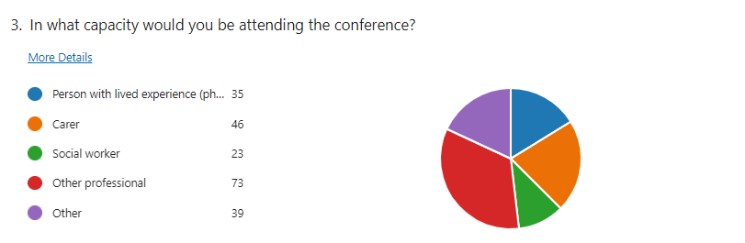
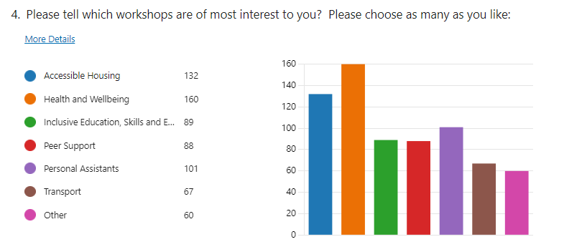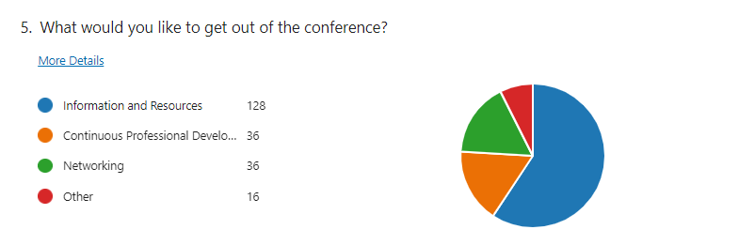

ILC Feedback Form
Data taken – 22/11/23
- 18 responses
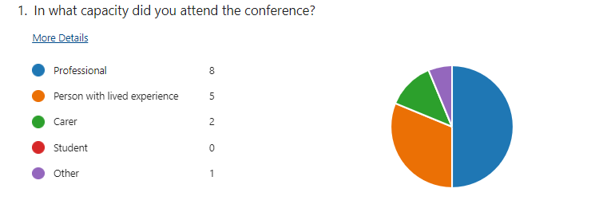

Feedback from the Conference

Below are some comments from people who attended the Conference:

“I really enjoyed participating in the Health & Wellbeing Workshop and it was a great opportunity to help inform the wider public on the intentions of the ICB to work with others as a system to reduce health inequalities, something which undoubtedly has impacted upon those who attended the session. It was great to have the Q&As following the presentation, to hear about real experiences and highlight how important it is to use lived experiences examples to help shape and inform service development. I hope that those who attended found it valuable and that any feedback received will support further events of this nature.”

“Hearing lived experience was very powerful, and in future, I wonder whether it would be useful to collate more of this (pre-event) so that responses to key themes can be more tailored/explored?”

“The conference was a timely reminder of the power of lived experience in shaping both the local and national agenda, not only within health and care settings, but in wider public life. There is clearly more we can do in the NHS to amplify the voice of lived experience, and act on the feedback shared to ensure services are genuinely accessible to all. I look forward to future events of this kind.”

“The workshops acknowledged the 'problems' faced by Adult Social Care and NHS but did little to restore confidence in the solutions being explored. Austerity, budget cuts, cost of living crisis, etc... are all important in explaining why we are where we are - but I would have liked to have had a clearer idea of what HCC and the participants can do to overcome these issues.”

“Liked the co-production and the "lived experience" of people. Aware more needs to be done to ensure funding by the Government, for living independently in our communities and not in residential/nursing homes etc.”

“It was nice to realise we are not alone, as a lot of us are in the same situation with trying to keep carers as we have not been able to give pay rises or added benefits like the blue light system.”

Conclusion and Next Steps

The Independent Living Conference was a success in:
- Celebrating 40 years of disabled people having choice and control over living independently.
- To bring together, people who use services with people who provide and plan services

Progress was made on these points and there is commitment on both sides but more work can be done
- Highlighting areas where improvements are required to give disabled people more choice and control over where they live and the community services they can access to improve their quality of life.
- Improving the opportunities for co-production to engage the Hampshire Adults’ Health and Care, Hampshire ICB and Service Users to engage in building services to further improve Independent Living.

The Conference shone a light on the hard work that has gone on over the past 40 years to create the Direct Payment Scheme, the Personal Assistants in Care market and how some disabled people live side-by-side with their local communities contributing and integrating. Independent Living continues to increase integration, choice and control of disabled people. The Conference plotted the story so far and also began to look at the future and how Independent Living could be improved. The challenging financial position for local authorities and the cost of living crisis threaten to undermine the work of the last 40 years and it is our shared responsibility to ensure this doesn’t happen. The Conference workshops only scratched the surface of six of the basic needs. It would have been possible to fill a whole day on each one.

PEP is committed to taking this word forward and working in Co production with others to improve independent living for disabled people in the future.

We would like to thank everyone who took part in this event and who helped to make it a success.

Rachel Harrison and Iain Speed, Co-chairs of PEP
May 2024

