Employer Hub Monthly Returns Upload Guide

This step-by-step guide explains how to upload and submit a Monthly Return file through the Employer Hub.
If you require further assistance, please contact Hampshire Pension Services via pensions.eoy@hants.gov.uk.

Before you start
Ensure that:
- The Monthly Return file has been completed in accordance with the Monthly Returns Specification and saved as a CSV file.
- The file includes all active LGPS members, including any who have left and joined the scheme during the pay period.
- The file includes all casual employees who remain active LGPS members, even if they have received no pay during the period.
- Any former members who have received a backdated payment during the pay period are included.
- The number of members is approximately what you would expect.
- The data is accurate and relates to the correct pay period.

Contents
Starting the Process 3
Stage 1 – Upload the file 7
Stage 2 – File Summary 11
Stage 3 – Submit the Data 16
Stage 4 – Validate Remittance Advice 18
Stage 5 – Final Checks 21
Queries 23

Starting the Process
- Log in to your Employer Hub account. If you experience issues logging in, please email pensions.employer@hants.gov.uk for support.

- Once you have logged in to the Employer Hub, you will be on the Dashboard: Home page. Select the Start a Process tile.
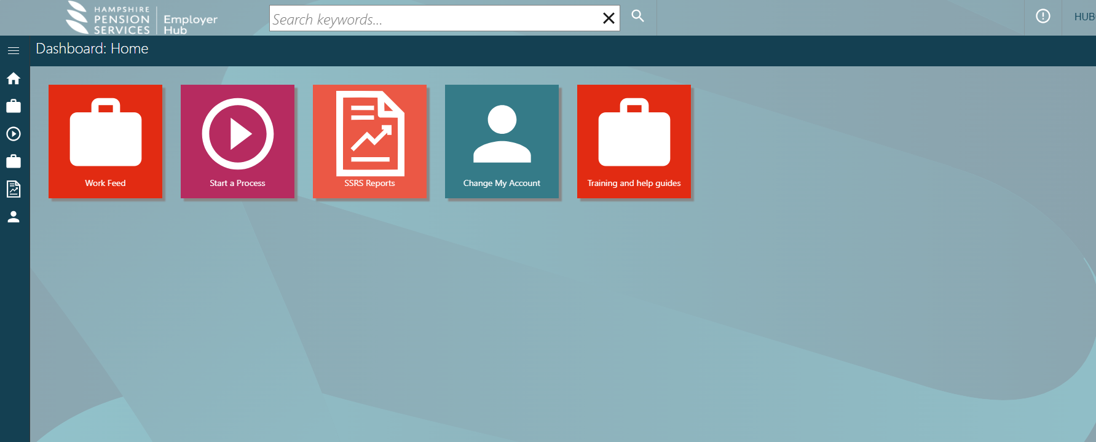

- Open the Employer forms HUB dropdown and select Hub Monthly Returns.

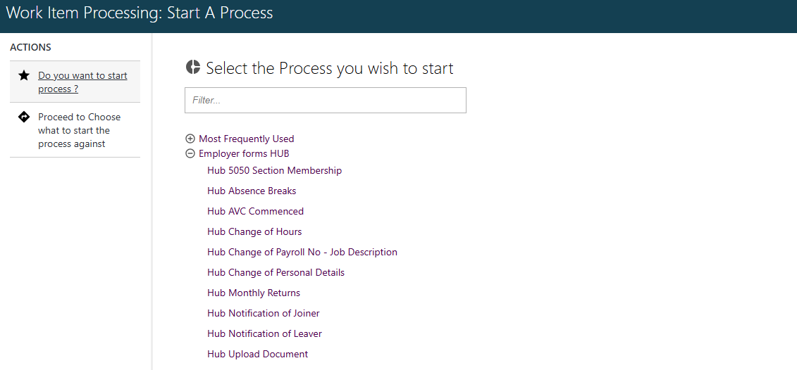

- Search for the employer that you wish to submit the Monthly Return file for. You can search using the employer reference number or the employer’s name. Full lists of employer reference numbers for each Fund can be found here. Select the magnifying glass icon and choose the correct employer from the list.
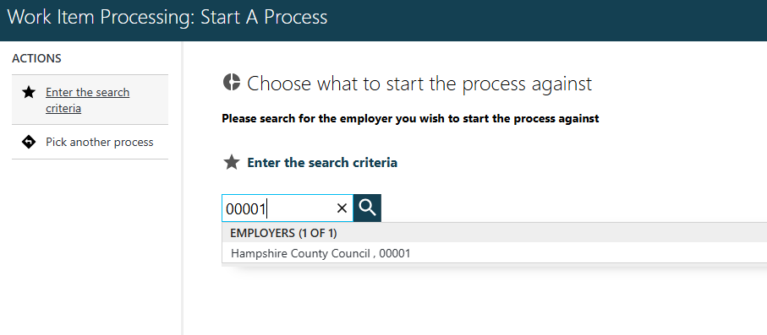

- Check that the Employer Details are correct, and then select Submit. This will open a Monthly Returns process.
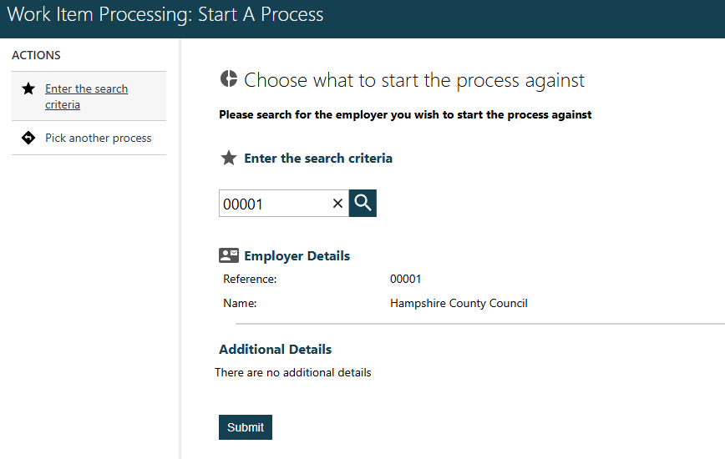

Stage 1 – Upload the file
- Enter the end date of the payroll period that your Monthly Return file covers. This is the last day of the relevant month. For example, if the file contains data for the period from 1 April 2026 to 30 April 2026, enter 30/04/2026.

To enter this, select Enter Return End Date on the left-hand side of the screen.
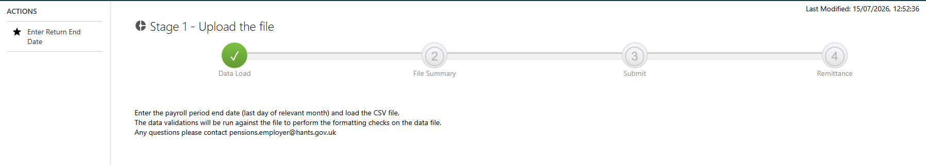
Enter the payroll period end date. Either choose the relevant date from the calendar or type the date into the box and then select Submit.

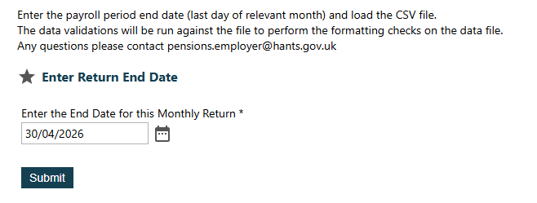
- Attach the Monthly Return file. Select Add File(s) and choose the relevant spreadsheet from your documents. The spreadsheet must be saved in one of the CSV formats.

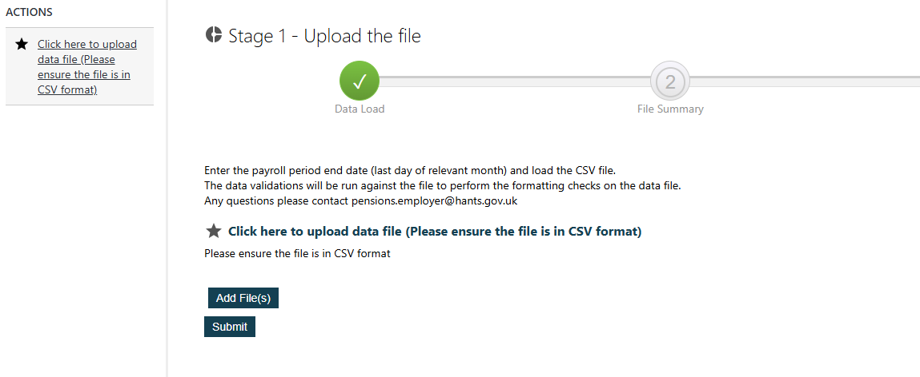

- Once selected, you will see the name of the file that has been uploaded. Check that this is the correct file and then select Submit.
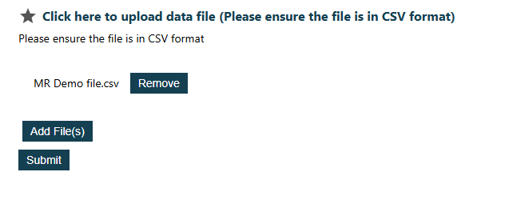
- The Monthly Return file then needs to be validated. Select Send to Validation.

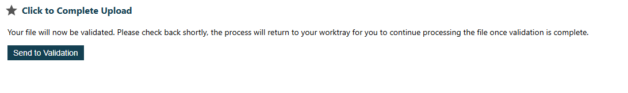

- You will then be taken to your Work Feed and will need to wait for the file to be validated. To refresh your Work Feed, select the Hampshire Pension Services logo above the Dashboard, and then open the Work Feed tile.

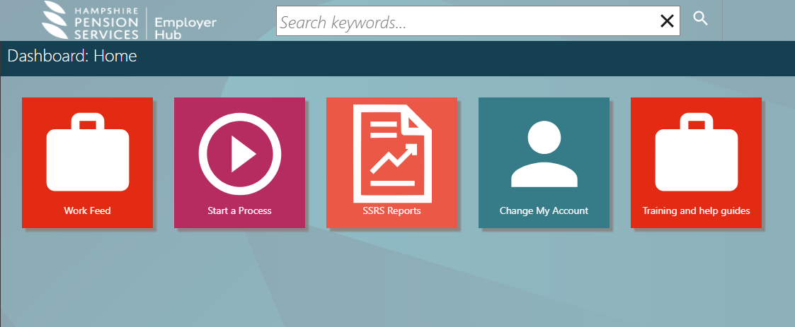
- Once the file has been validated, a task titled Monthly Returns – Employer Upload – Check File will appear in your Work Feed. Open this task to proceed to the next stage.

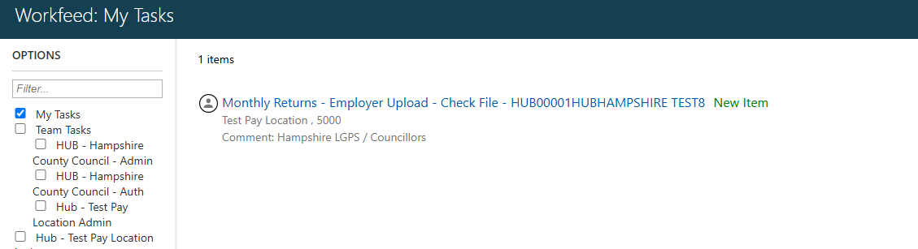

Stage 2 – File Summary
- A summary of the file that has been uploaded will open. This will show the number of rows from the file with Warnings or Errors which need to be checked and resolved. Select Proceed to Stage 2a Data Correction on the left side of the screen.

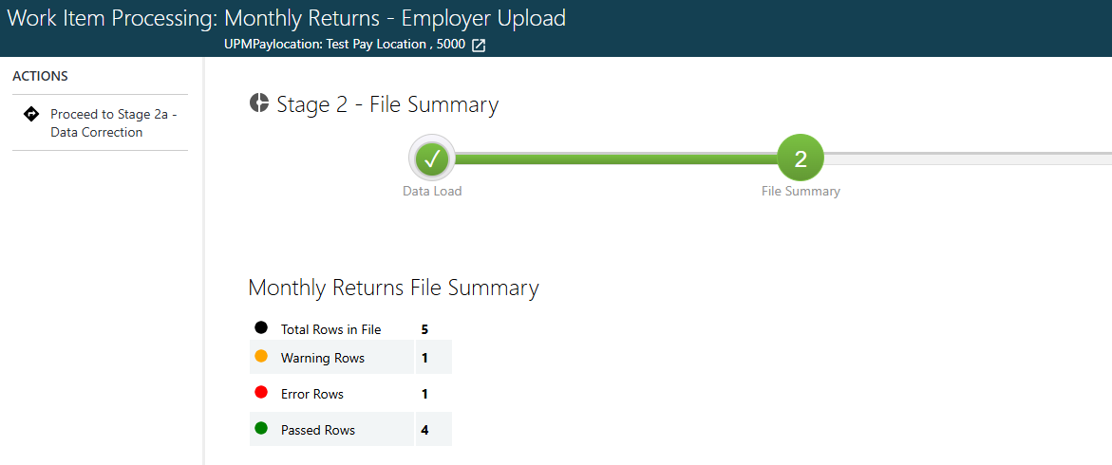

- You will then see each line of data that was included on the file and any errors or warnings that have been generated.

Select each row with errors or warnings and click Edit row to make the required corrections, or you can select Reject and Rollback Imported Data on the left side of the screen if you wish to make the corrections on the original CSV spreadsheet (this may be quicker if there are multiple of the same error in the file).
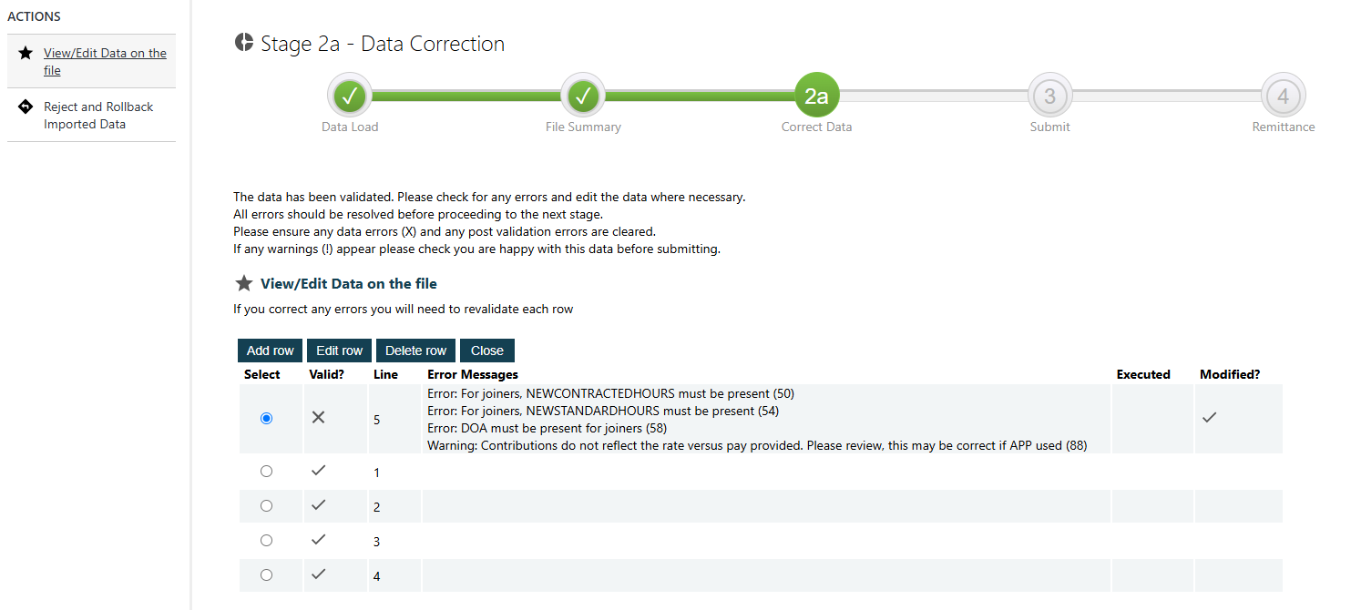
Understanding validation results:

Result | Meaning | Action Required
Error | Mandatory information is missing or invalid. | The data must be corrected before proceeding.
Warning | The data appears unusual but may still be correct. | Review and check whether the data is correct. Amend if it is incorrect.
Valid (no errors or warnings) | No issues have been identified. | No action required.

- If you choose to edit a row within the process on the Employer Hub, you can change the data that was uploaded from the original Monthly Return file. For example, to resolve the errors against the row shown below (on the right side), you must add the employee’s date of admission to the LGPS under DOA and add their new contracted and standard hours. To address the warning, you would need to check whether the employee contributions or contribution rate are correct.
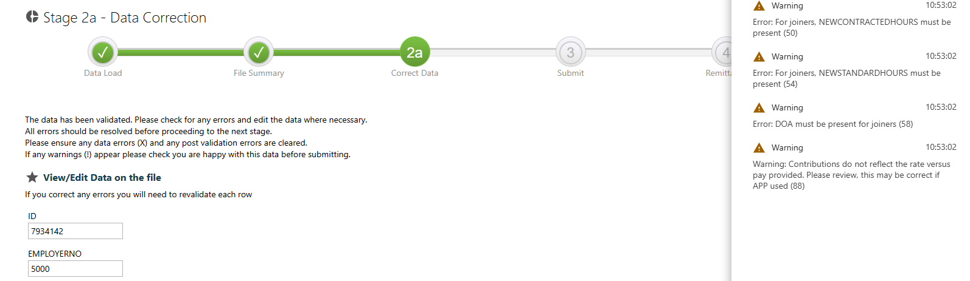
Scroll to the relevant headings and make the required additions or changes to resolve the errors.

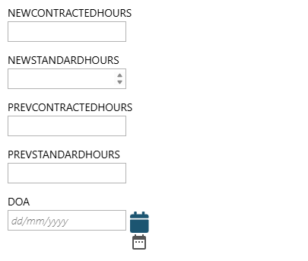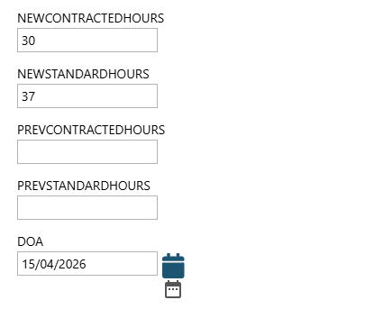

- Once you have made the required changes to a row, scroll to the bottom of the screen and choose Save & Validate.

- Once all errors have been corrected and cleared, and all warnings have been reviewed, select Close.
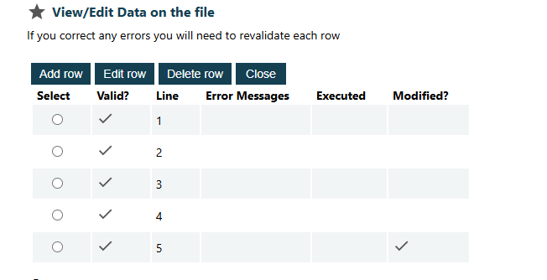
- Select Next on the left side of the screen.

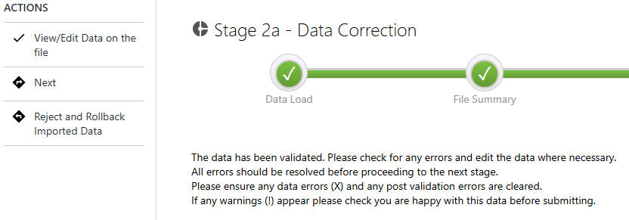

- A summary of the Monthly Return file will be shown again. Select Next on the left of the screen to proceed to the next stage.

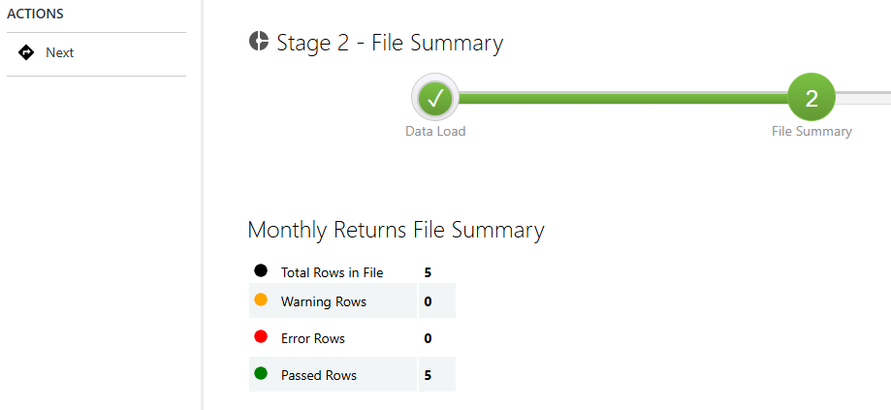
Stage 3 – Submit the Data

- The list of rows of data from the Monthly Return file will be shown again. Ensure that there are no outstanding errors, and then select Close.

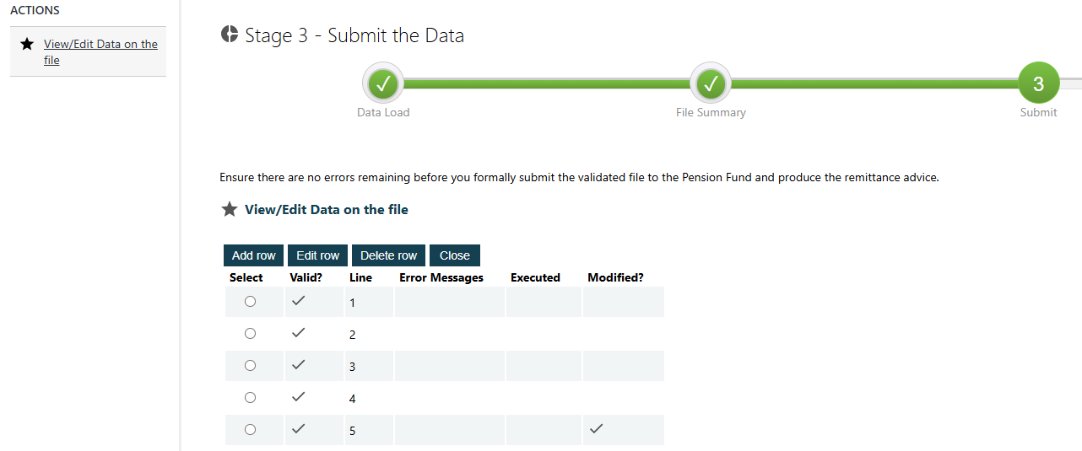

- Select Submit the Data on the left side of the screen.

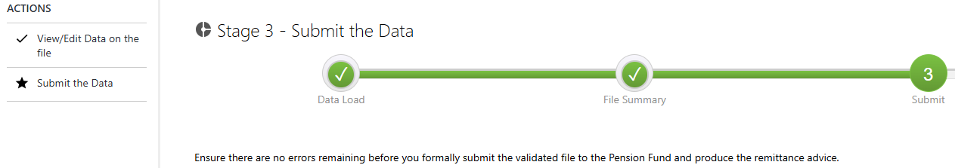

- Select Next on the left side of the screen.
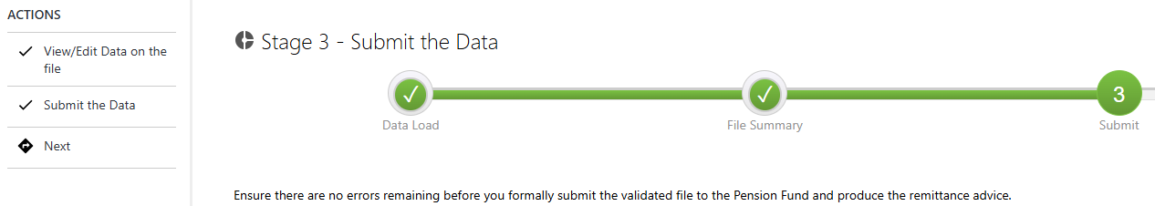

Stage 4 – Validate Remittance Advice

- The financial totals of the remittance advice will then be shown. Scroll along to view the total under each column. Ensure that all financial totals shown are correct. Select the row once you have reviewed these and click Edit row to validate the data.
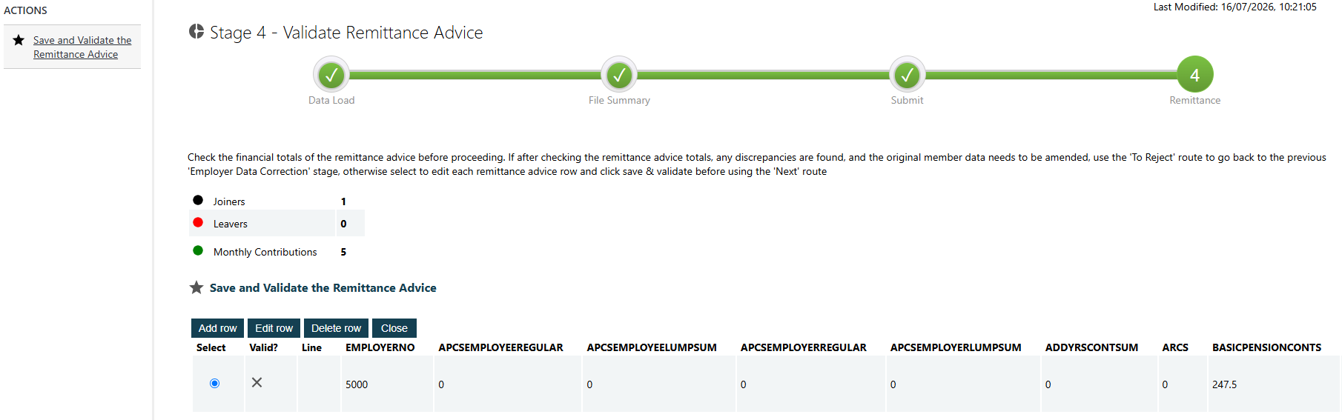

- Select Save & Validate.

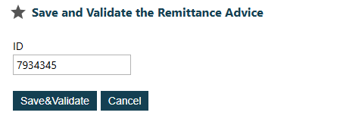

- A tick will then appear under the Valid? column. Select Close.
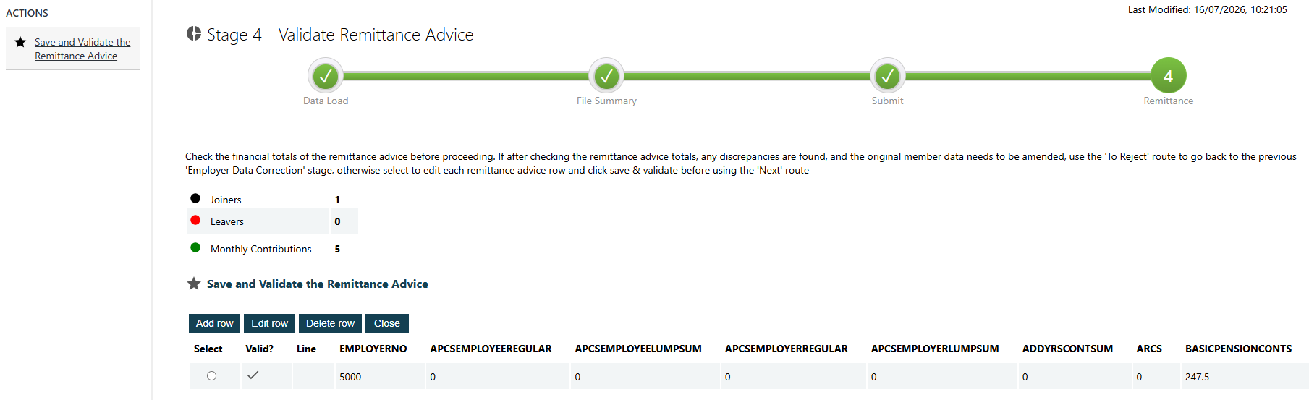
- Select Next on the left side of the screen to proceed to the final stage. If you have identified any discrepancies with the remittance and need to amend the original member data, select To Reject to return to the previous stage.
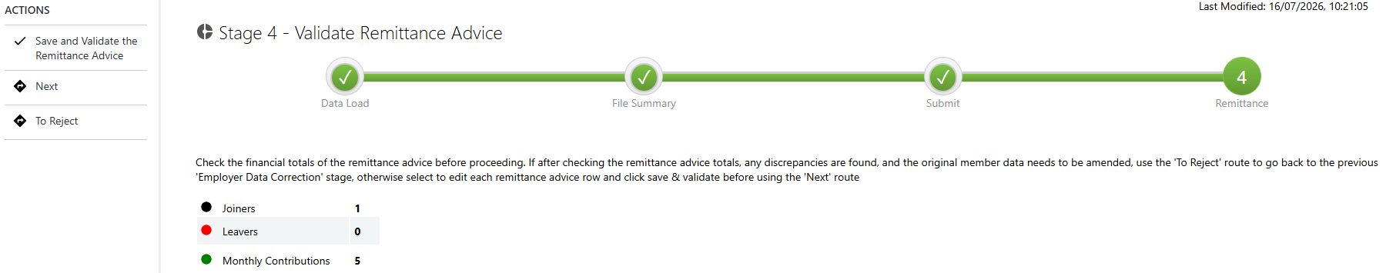

Stage 5 – Final Checks
- Select View Remittance Advice on the left of the screen.
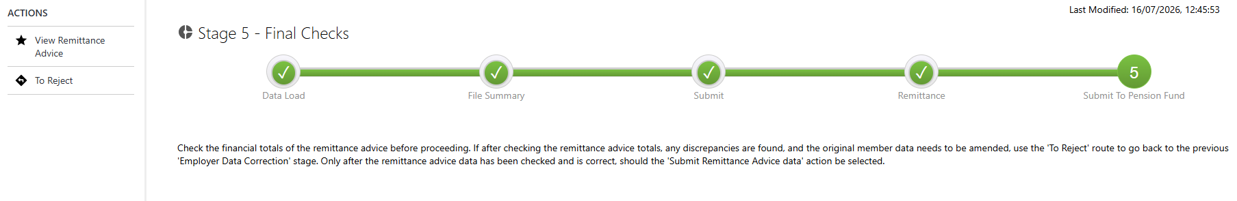

- Ensure that the financial totals are correct before selecting Submit Remittance Advice.
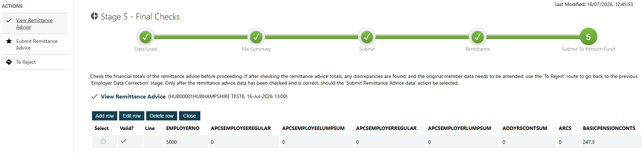
- Select Submit to Pension Fund to complete the upload of your Monthly Return file.
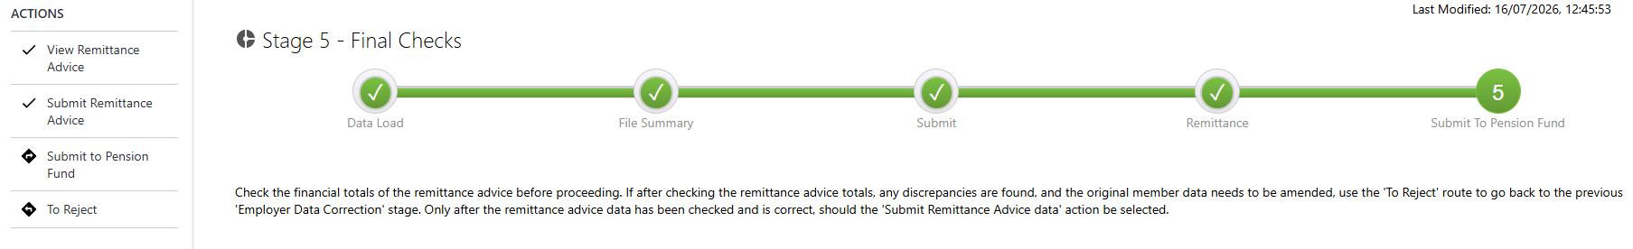

Queries

After you have submitted a Monthly Return file, Hampshire Pension Services will process the data provided. We may identify queries with the submission, which will be communicated to you in different ways depending on the type of query.

Type of query | How it will be raised
Missing Member Data/Leaver queries | Raised through the Employer Hub and sent to the scheme employer’s Group Tray.
Other query (e.g. data query) | Sent by Hampshire Pension Services via email to the contact who submitted the Monthly Return.

Missing Member and Leaver Queries
We may identify members on the submission who have a leaving date during the pay period for whom we have not received a leaver form, or members with active pension records who were not included on the Monthly Return.
These queries will be raised and can be found in your scheme employer’s Group Tray on the Employer Hub. Once we have uploaded your submission, you will receive an email which prompts you to check the Group Tray and resolve any queries that have been raised.

If any of these queries have been raised, they will appear in the employer’s Group Tray as below. To reassign the processes, select the relevant processes and select Reassign Processes on the left side of the screen. Choose the relevant user from the list to assign the processes to.
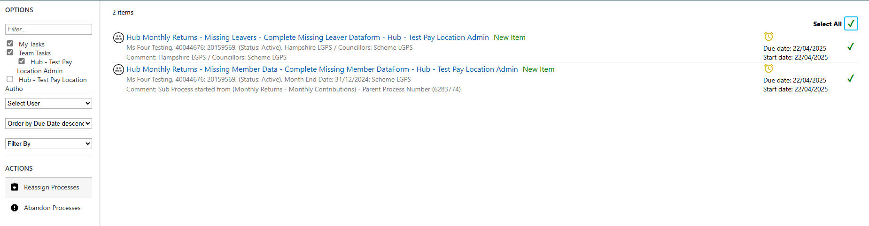
Missing Member Data form
The Missing Member Data form will explain the issue and ask you to confirm whether the member should have appeared on the Monthly Return.
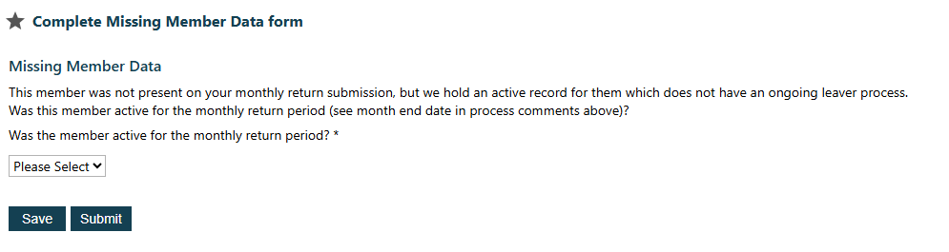
If the member should not have been included (for example, because they left before the relevant month or for another valid reason), provide an explanation in the box provided.
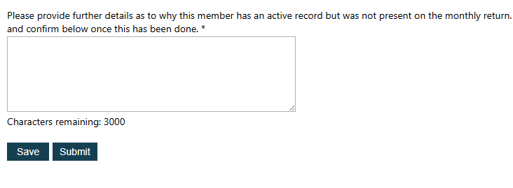
If the member should have been included on your monthly return, complete the form with the requested information. We will then use this information to update the member’s record.
Missing Leaver Data form
The Missing Leaver Data form will explain the issue and ask you to confirm whether the member has left the LGPS.
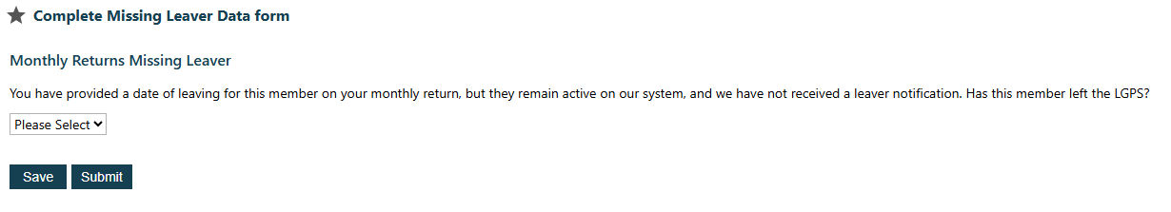

If they have left the LGPS, complete a leaver notification on the Employer Hub, return to the Missing Leaver Data form process and confirm that this has been completed. You must confirm that a leaver form has been submitted before completing the Missing Leaver Data form process.
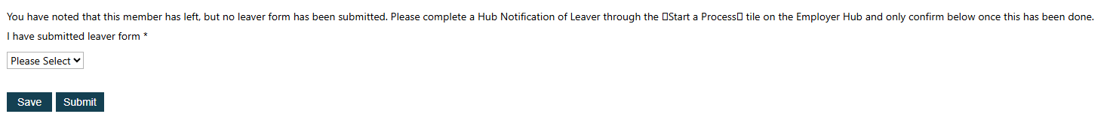
If they have not left the LGPS, provide further information so that Hampshire Pension Services can review and update the member’s pension record if required.
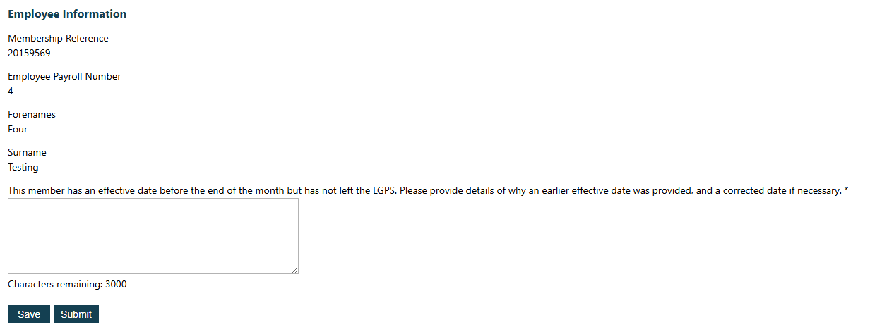
Other queries
If Hampshire Pension Services identify any other queries which do not relate to missing member or leaver notifications, or if further information is needed to complete the Monthly Return submission, we will contact the person who submitted the Monthly Return file via email. These queries often include:
- Queries for members who appear on the Monthly Return submission who have not been marked as a new joiner, for whom we do not already hold an active record.
- Queries relating to discrepancies between members’ personal details submitted on the Monthly Return and those held on Hampshire Pension Services’ records.
- Queries regarding members’ pensionable pay or contributions figures for the payroll period.
Hampshire Pension Services will explain any queries in the emails sent, including what information is required from the employer or payroll provider to resolve the query.
Further support
If employers or payroll providers have questions about Missing Member and Leaver Queries that have been generated on the Employer Hub, or about queries they have received via email, contact pensions.eoy@hants.gov.uk for support.

